

**User Manual and Technical Report**

**Available on**

**Project Name:** MeetingRoom Pro (MrPro)

Github: <https://github.com/Virksaabnavjot/MRPro>

Website: [https://navsingh.org.uk/mrpro/](http://roomassistant.navsingh.org.uk)

Documentation: [Github Repository here](https://github.com/Virksaabnavjot/RoomAssistant-Documentation-Repo)

**Project Aim:** The aim of the project is to develop a client IOS application and a Web-API that exposes data from the database to client.

**Project Summary:** In day to day life weather its work, college or hotel buildings people find it hard to find rooms, even if the people have been working in the same company for years they are not familiar with all parts of the building and the rooms available in it. The problem arises when there is a time shortage and you have to find the room and make on time for the meeting.

So, MRPro will help its users to find and navigate to the different parts of the building.

Students face these problems too, MRPro can help new students to get familiar with their college building, the app can also be used by city council for different buildings and malls to assist the people (everyone including people living in the city and tourists), moreover hotels can make use of the application to provide exceptional experience for their users.

Doing the project was such a great experience as I learned so many new things while doing this project – Example the technologies I used for this project I learned them from scratch i.e by finishing this project I now know few extra technologies – Swift 3, Php, CodeIgniter, Geo-Spatial Data storing and manipulation (in two different languages actually – JavaScript and php).

The project was quite difficult as their was not very clear documentation available on new Geometry types, i.e spatial data types to store and retrieve data from the database, the core challenge of the project was to find solution to this problem through research which took a long time as the document was not available I had to try so many things to before solving the problem (the same way Thomas Edison had to try 1000’s of times before he invented the light bulb and these days the bulbs are everywhere, cheap and easy to manufacture but doing it for the first time is always hard and challenging) and then implement the project. Other, factors were I was new to all the technologies I was using for this project so their was a big learning curve.

I believe the project has accomplished its goals and requirements that were proposed in the Technical report, the project has turn out to be innovative (their no other project in the iOS or other markets that is using geometry data types in SQL and providing features like building and room listings, maps, gallery, bookings and more all combined in one product), the project is exploiting new technologies (SWIFT) and features (Geometry data in SQL) and despite me having some serious health issues this year from which I am still recovering, but I believe all the challenges I faced actually have made me more stronger mentally that I should keep going and pass all the hurdles in the way either health related issues, financial problems others. Moreover, college was very supportive in understanding the health circumstances.

**Key Features:**

**IOS APP Features:** MRPro allows you to - Find, Book, Review, Look at the Room Photos, Upload Photos, Help Navigate to the room using a map with building drawn on it and room pointed on it.

**WEB API Features:** Retrieve data from the database and return it to the IOS application in JSON format when requested.

|  |
| --- |
| Name: Navjot Singh Virk |
| Student Number: X13112406 |
| Email: virksaabnavjot@gmail.com |
| Year: 4th (Software Development Stream) |
| Course: BSc. Honors in Computing at National College of Ireland *(2013-2017)* |

Table of Contents

1 User Manual 6

Executive Summary 7

2 Introduction 8

2.1 Background 8

2.2 Aims 8

2.3 Project Commercialization 9

2.4 Technologies 9

2.4.1 Technology Changes 13

2.5 Structure 14

3 System 16

3.1 Requirements 16

3.1.1 Functional requirements 16

3.1.2 Requirement 1: Easy to Use GUI 17

3.1.3 Requirement 2: List and Find(Search) 17

3.1.4 Requirement 3: Map / Navigation 18

3.1.5 Requirement 4: Geo Location Notifications 19

3.1.6 Requirement 5: User Registration 20

3.1.7 Requirement 6: Booking System 21

3.1.8 Requirement 7: Photo Gallery 22

3.1.9 Requirement 8: Photo Upload 22

3.1.10 Requirement 9: Review 23

3.1.11 Requirement 10: My Meetings 24

3.1.12 Requirement 11: Call 24

3.2 Non-Functional Requirements 25

3.3 Data requirements 27

3.4 User requirements 28

3.5 Environmental requirements 28

3.6 Usability requirements 28

3.7 Design and Architecture 29

3.8 Implementation 30

3.8.1 Getting Started with Project development 30

3.8.2 Client Side Implementation 40

3.8.3 Server Side Implementation 42

3.9 Graphical User Interface (GUI) Layout 43

3.10 Testing 47

3.11 Customer testing 47

4 Conclusions 49

5 Further development or research 50

6 References 51

6.1 Research and Code 51

6.2 Images 51

7 Appendix 53

7.1 Independent Research (Problem Solving – Storing Geo-Spatial data) 53

7.2 Project Proposal 56

7.2.1 Objective 56

7.2.2 Background 57

7.2.3 Technical Approach 57

7.2.4 Special resources required 60

7.2.5 Gantt Chart 60

7.2.6 Technical Details 61

7.2.7 Evaluation 61

7.2.8 Proposed Supervisor 62

7.3 Project Plan 63

7.4 Requirements Specifications 64

7.4.1 Introduction 64

7.4.2 User Requirements Definition 66

7.4.3 Design Thinking for User Requirements Definition 67

7.4.4 Requirements Specification 67

7.4.5 Interface requirements 77

7.4.6 System Architecture 81

7.4.7 System Evolution 82

7.5 Monthly Journals 83

7.5.1 Reflective Journal 1 83

7.5.2 Reflective Journal 2 85

7.5.3 Reflective Journal 3 (November) 87

# User Manual

|  |  |
| --- | --- |
|  | Steps to use the application. |
| Step 1 | – Install the app |
| Step 2 | – Make sure you have an active internet connection to use the application. |
| Step 3 | – Open the app |
| Step 4 | – Sign in as a user (the companies can limit user signup to their company email addresses only or admin can have the choice to pre-register users and only provide only login option). |
| Step 5 | – Login with your detail |
| Step 6 | – You will see your profile page  Provide profile page and description, include image and point out the navigation options  Here, on this ­­screen you will see your profile details, like your username and email, from here you can procced to – Building List and Search, or you can open the help page that provides short user manual within the app to help users quickly learn using the app. |
| Step 7 | – Building List and Search – Here you can search and find a list of available buildings (the buildings can be from different locations (buildings in different cities of the countries i.e city-country), that is globally a building can be in Dublin-Ireland, Galway-Ireland, Banglore-India) |

# Executive Summary

With MeetingRoom Pro I have looked to develop a user friendly IOS application to solve the problem of finding meeting rooms in large buildings. I aimed to address a problem I had encountered personally in the past during my work placement and other people i.e. finding meeting rooms is complex and inconvenient. The application is designed in a way that it can be easily tailored for the use of any organization, with change in data provided through API i.e. building and meeting room coordinates. The app will be available for iPhones and iPads. The application will help people find rooms with ease and navigate through the building with their location shown on the map and also have the option to book the rooms straight from the app. App client will be developed using Swift 3 and Xcode Ide.

# Introduction

## Background

During my work placement at SAP SE, I was engaged in several meeting from my induction to my farewell meeting, there were more than 50 meetings, from team meetings to global team meetings, intern meetings and HR meetings, to employee farewell meetings which I was part of in the course of 7 months of internship.

And number one issue was finding the meeting room due to big size of the buildings, if the meeting room was close enough to my desk, it was easy enough to find the meeting room but the problem used to arise when the meeting rooms were on different floors, even different wing of the same floor and the problem was big when trying to find a meeting room on another building and some fancy names to the meeting rooms didn’t make much sense at all and the icing on the top if you are short on time i.e. have consecutive meetings to attend and the only solution available was to ask you collages if they didn’t know run towards the reception and they would show you a floor plan which sometimes didn’t made sense and overall experience in finding meeting rooms was not up to the standards to which it could be achieved.

I started some research and found other employees were facing the same issues and were just limited to using meeting rooms near their offices due the hassle of finding meeting rooms, after talking to people the user research findings were not just the interns who felt this pain, some of the very senior employees which were there for many years didn’t know where some of the meeting rooms were and since SAP is multinational company, there were always employees from different location which travelled to attend meetings and had very hard time finding the meeting room and first have to go to facilities department and the facilities member would manually assist wherever this process can be automated i.e. a simple to use application could solve this problem.

Hence, there is were the idea for the application is developed from but it is not just limited to corporate world the application can be put to use in universities and college with minor changes.

## Aims

The aim is to develop an easy to use mobile application that will help people find meeting rooms with ease in a big building and provide some other useful functionality like:

Map and Navigation – The user will select a meeting room and the application shall be able to show a detailed map with navigation instructions to the room.

Room Booking – When a user wants to book a room they can do.

Proximity Alerts - When a customer device comes within a radius of the meeting room in which they have a meeting soon they will receive a notification saying you are this close to the meeting room and they can start the navigation.

I will describe the rest of the functionality in the Systems Requirements section.

The application has the potentially to be adapted internationally because of its scalability. There is very high possibility that business organizations, universities and colleges will buy the application for use for their staff and students. Essentially the app can become a valuable resource to any individual or organization and provide extraordinary results for people using it.

## Project Commercialization

I wouldn’t be wrong if I say most business projects are developed with the goal of make profits, commercialization of the project is a very important factor in the development of the project and moreover continued development of the software project. I believe this project has a great commercial scope as it can be used in multiple industries naming few the potential customers –

Multinational Co-orperate companies

SAP, Google, Yahoo, Microsoft, Apple Inc, etc

As these companies are huge, have buildings and meeting rooms all over the world, mostly multiple buildings in at one location. MRPro can be used by these companies and their employees to find and book meetif

## Technologies

|  |  |
| --- | --- |
|  | Programming Language |
| I decided on Swift 3 as my primary coding language for my application development. I came across Swift as a language during my internship and have a beginner level understanding of the language and would like to advance my understanding of the language through this project. Swift is a fairly new language and is open source and moving towards cross-platform which will open new possibilities in the future. I find Swift to be a fast and versatile language.  Below are some other features of Swift that provided me with motivation to use it for my final year project.    Image Source: <http://mlsdev.com/en/blog/51-7-advantages-of-using-swift-over-objective-c> | |

|  |  |
| --- | --- |
|  | PHP Framework |
| In the mid-term report I mentioned to use JavaScript for my backend but later in the development I decided to move forward with Code Igniter (because I decided to change my database from SAP Hana to MySQL database – Please refer technology changes section of the report for more details) which is a PHP framework which helps to easily develop web applications and api’s.    Image Source : <https://codeigniter.com/> | |

|  |  |
| --- | --- |
|  | Integration: Using Cocoa pods (in pod file)   * Pod ‘SwiftyJSON’ |
| In Swift, I have experienced its not very easy to parse JSON, So, I have decided to use an open source Swift library SwiftyJSON to help me with parsing JSON data that the application client will receive from web service | |

|  |  |
| --- | --- |
|  | Cocoa pods are used as an dependency manager for iOS application projects. |
| Cocoapods helps to easily add framework to your ios projects through pod file. Cocoapods installation details are added in Getting Started with Project development section of the report.  Pod file example: | |

|  |  |
| --- | --- |
|  | Integration: Using Cocoa pods (in pod file)   * Pod ‘Alamofire’ |
| In Swift, NSURLConnection class helps to start and stop http URL requests, Alamofire is a library that helps make http request more elegantly with less code (and helps write more cleaner code too).  Below are the Usage details for Alamofire:    Image Source: <https://github.com/Alamofire/Alamofire> | |

|  |  |
| --- | --- |
| Xcode Ide | Code Editor |
| Xcode IDE was chosen for the development of the application client as it’s the default editor for developing IOS Swift apps. Other options were AppCode from JetBrains. | |

|  |  |
| --- | --- |
| Github.com | Version Control |
| For source control I am using Github. As, it allows me to keep my code available anywhere not worrying about losing it. | |

|  |  |
| --- | --- |
|  | Server Side Scripting Language |
|  | |

|  |  |
| --- | --- |
|  | Relational Database |
|  | |

|  |  |
| --- | --- |
|  |  |
|  | |

|  |  |
| --- | --- |
|  |  |
|  | |

|  |  |
| --- | --- |
|  |  |
|  | |

**Other technologies used:**

WordPress (HTML,CSS, PHP and MySQL) is used to create a business website for the project. The aim of the website is to provide a professional outlook to the application project and work as a marketing tool, help attract customers, shareholder and potential angel investors etc.

### Technology Changes

During the final development of this project some changes to proposed (during Mid-term) technologies were made. They are as follows –

|  |
| --- |
| SAP Hana was replaced with MySQL |
| Database change – Later, during the development of the project I decided to use MySQL database instead of SAP Hana which being used to store geo-spatial data. |
| Reason for Change: During the mid-term I struggled to find appropriate resources/solution to store geo-spatial data in MySQL, which lead me to use SAP Hana for geo-spatial data storage because some documentation was available for it. But, Hana came with some disadvantages which forced me move back to MySQL.  Problems with Hana: I was using Trail, which had certain limitations like database needed a restart every 12 hours and database was automatically removed/deleted if not used for 6 day. The pro version of Hana is expensive and I decided to research more on storing geo-spatial data in MySQL. |
| JavaScript replaced with PHP (CodeIgniter) |
| Language Change: When using Hana I was using JavaScript in .xsjs file whereas |
| Reason for Change: Using JavaScript was no more a must requirement when I moved from Hana to MySQL. I wanted to learn something new things and get job ready while doing this project and I had never worked with PHP before so when it came between choosing Java (Jersey) or PHP for Web API development I choose PHP so I can learn a new programming language. |

## Structure

The structure of this report allows the reader to receive a general overview of the project with the first section. Here the background, aims, and technologies will be detailed, allowing the reader to better understand the direction the project was to take.

The second section details the system and the requirements. Here will list the necessities that must be implemented as to allow the software to be functional and successful.

This section will also detail the design and architecture of the system, as well as describing the implementation and the use of the graphical user interface. Finally, this section will also touch on testing of the software.

The third section provides any concluding thoughts I had regarding the project and its development.

With the fourth section I have detailed any potential development plans for the project, describing the areas in which it can grow post submission.

The fifth section details any references, listing the resources used throughout the project development.

The sixth section contains the appendices, containing the original project proposal, project plan, requirement specification, and the monthly journals.

# System

## Requirements

### Functional requirements

Use Case Diagram

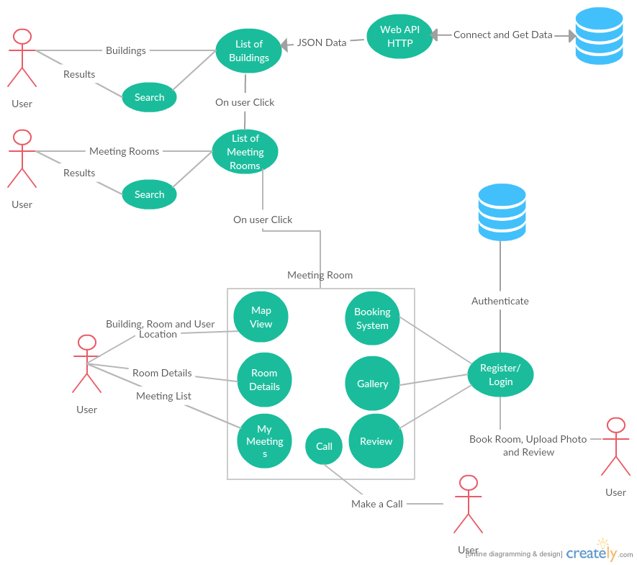

The above Use Case Diagram provides an overview of all functional requirements of this project.

### Requirement 1: Easy to Use GUI

#### User Story

As a user I want to have an easy to use interface so as I can navigate through the app easily with little time needed to be spent learning how to use the app

#### Description & Priority

The system shall have an easy to use graphical user interface. Navigation will be possible through the touch screen functionality of the IOS device. The design shall also be responsive so as to support different screen sizes of iPhones and iPads.

*Essential and High Priority Requirement*.

#### Requirement Activation

This requirement will be activated upon starting of the application.

#### Technical Issues

GUI Need internet connection to get data from API which will be shown in the application, slow internet connection can affect performance of the GUI.

#### Risks

Provision must be taking that not all users have a good understanding of technology and the use of mobile platforms. If the GUI is to become too complex, some users may not use the application. This requirement is at the core to the success of the system.

#### Dependencies on other requirements

N/A

### Requirement 2: List and Find(Search)

#### User Story

As a user I want to be able to find buildings and meeting rooms with ease. Like a clickable list of buildings which then browse to list of meeting rooms also search and I can select a meeting room and find it or use other features like room booking, gallery upload etc.

#### Description & Priority

The system shall allow to search and also provide list of available buildings and meeting rooms.

*High Priority*

#### Requirement Activation

The requirement to list buildings and meeting rooms will be activated upon starting of the application and search is activated when user enters in search bar.

#### Technical Issues

N/A

#### Risks

This requirement is at the core to the success of the system as most of the requirements hereafter have a dependency on this one.

#### Dependencies on other requirements

This requirement has a dependency on requirement 1 - Easy to use GUI.

### Requirement 3: Map / Navigation

#### User Story

As a user I want to be able to view the building highlighted on the map. Also the meeting room I am looking for along with my current location and some information about the building and room like floor number.

#### Description & Priority

The system shall have an expandable map with current location of the user and building drawn on the map.

*Optional: The application should leverage some sensors or beacons implemented in the building for effective indoor navigation as GPS may not provide accurate location indoors.*

#### Requirement Activation

The requirement will be activated when the user selects a meeting room from a list of rooms.

#### Technical Issues

N/A

#### Risks

May face some issues with current location of the user while indoors as GPS is not designed for indoors and this may affect the accuracy of the location slightly.

#### Dependencies on other requirements

N/A

### Requirement 4: Geo Location Notifications

#### User Story

As a user I want to have notifications automatically sent to me when within a certain radius of the building or the meeting room so I am notified that the destination is close enough.

#### Description & Priority

The system shall have functionality that when a user’s smart phone comes within a certain radius of the meeting room a notification will be sent to remind them with approx. distance to the destination i.e. *"Hey,… you are “approx. distance” from your destination ….".* Functionality to unsubscribe to this service should also be provided. *High priority*.

#### Requirement Activation

This requirement will only be activated if a user brings their mobile device which they have the app installed on within a certain radius of the building/meeting room. This distance will be tweaked at the system/ user testing stage of project. This service should also only occur once while finding a meeting room as if a client user was moving in and out of the geographical perimeter they will not receive multiple notifications. As stated above functionality to unsubscribe to this service should also be provided.

#### Technical Issues

N/A

#### Risks

N/A

#### Dependencies on other requirements

N/A

### Requirement 5: User Registration

#### User Story

As a user I shall be able to easily register within seconds to use the advanced features like posting reviews and uploading photos.

#### Description & Priority

The system shall provide a standard registration and login. The requirements like booking and reviewing require registration in order to allow users to use these features.

*High Priority*

#### Requirement Activation

The requirement is activated when user wishes to book, review meeting room and upload photos of the meeting room.

#### Technical Issues

N/A

#### Risks

N/A

#### Dependencies on other requirements

N/A

### Requirement 6: Booking System

#### User Story

As a user I want to be able to book meeting rooms through my smartphone so as I can book meeting rooms easily from anywhere.

#### Description & Priority

Functionality for users to book meeting room once selected a meeting room. This feature shall have its own page and be easy to use i.e. drop down lists to choose data and time of booking and the user shall be able to see the booked meeting rooms.

*High priority*

#### Requirement Activation

This requirement will be activated if the client user wishes to book a meeting room.

#### Technical Issues

N/A

#### Risks

This requirement is very important as some of the requirements hereafter have a dependency on this one.

#### Dependencies on other requirements

This requirement has a dependency on requirement 1 - Easy to use GUI and Requirement 2 – List and Search

### Requirement 7: Photo Gallery

#### User Story

As a user I shall be able to see some photos of the meeting room showing the equipment available and size of room straight from the app.

#### Description & Priority

The system shall have a photo gallery with multiple photos of the room.

*Medium Priority*

#### Requirement Activation

The requirement will be activated when a user selects a meeting room from the list.

#### Technical Issues

N/A

#### Risks

N/A

#### Dependencies on other requirements

N/A

### Requirement 8: Photo Upload

#### User Story

As a user I shall be able to upload some picture from my phone gallery or camera if some pictures are missing in the Gallery.

#### Description & Priority

The system shall allow all registered users to upload images of the rooms to the photo gallery. And also allows users with admins and moderator accounts to delete the low quality images straight from the app.

*High Priority*

#### Requirement Activation

The requirement will be activated when user wishes to upload an image.

#### Technical Issues

N/A

#### Risks

Some users may try to spam or misuse this feature.

#### Dependencies on other requirements

The requirement has a dependency on requirement 7: Photo Gallery

### Requirement 9: Review

#### User Story

As a user I would like to see some reviews available about the room and its equipment and also like the functionality to review it myself.

#### Description & Priority

The system shall allow the registered users to review meeting rooms based on different parameters like – functionality and quality of available equipment, if the room temperature was good and so on as user feedback will help improve the quality of the meeting rooms and the meeting rooms getting low ratings can be improved and get more attention from IT and Facilities department.

Medium Priority

#### Requirement Activation

The requirement will be activated when the user wishes to review meeting room.

#### Technical Issues

N/A

#### Risks

N/A

#### Dependencies on other requirements

N/A

### Requirement 10: My Meetings

(Calendar event / Reminder of booked meeting feature)

#### User Story

As a user I would like to see all my meetings and simply start the map navigation.

#### Description & Priority

The system shall provide a list of meetings booked for the user and the user will receive a reminder notification. The system should be able write and read meetings to and from the device calendar.

#### Requirement Activation

The requirement will be activated when the user has some meetings in their calendar.

Medium to Low Priority

#### Technical Issues

N/A

#### Risks

N/A

#### Dependencies on other requirements

The requirement has dependency on requirement 6: Booking System

### Requirement 11: Call

#### User Story

As a user if I am in a meeting and some equipment is not working I should be able to contact the key contacts for the room that can fix the problem for me i.e. make a quick call from the app.

#### Description & Priority

The system shall provide contact information for key contacts and allow user to make a call.

#### Requirement Activation

The requirement is activated if the users wishes to make a call through there phone.

#### Technical Issues

N/A

#### Risks

N/A

#### Dependencies on other requirements

Requires a sim card to make calls via the phone.

## Non-Functional Requirements

#### Scalability requirement

##### User Story

N/A

##### Description and Priority

With regards to the intended number of users in big and medium cooperate organisation with thousands of employees and teachers and students in educational institutes and the projected load scenarios, the intention is for the system to be able to serve queries in thousands/ day (in large part during the 9-5 peak traffic hours) and the application shall also be scalable to use for any organisation with little to no changes to the app’s code.

*High Priority*

#### Availability requirement

##### User Story

As a user I want to be able to access the app at any time I wish.

##### Description and Priority

The app shall be accessible at any time of the day on any day of the year. *High priority*.

#### Physical requirement

##### User Story

As a user I want to be able to access the app from anywhere.

##### Description and Priority

The app shall work on mobile devices. *High priority*.

#### Security and Privacy requirement

##### User Story

As a user I want the app to be secure like my password must be safe.

##### Description and Priority

The app shall achieve security through encryption and SSL certificate when connecting to the server. *High priority*

#### Reliability requirement

##### User Story

As a user I want to the app to be reliable.

##### Description and Priority

The app shall be reliable i.e. stable and consistent of what is expected out of it. *High priority*.

#### Maintainability requirement

##### User Story

N/A

##### Description and Priority

The app shall be easy to maintain on daily basics, and it should be easy to fix bugs, add new features, increase performance and easier for others to maintain the software.

*High Priority*

## Data requirements

It has been mentioned before in the document that the application can be tailored for the use of any organization with a simple change of data provided. Which gives you an idea that data plays a major role in this project.

The database will store data/information about buildings and meeting rooms along with reviews, bookings and more.

JSON – Data is transferred through JSON using XSJS service.

SAP Hana Database to store all the data regarding buildings, rooms, bookings, meetings

Web hosting/Cloud – store images for the use of gallery and upload feature.

So, far I have designed two tables (listed below) for the database which will store building and meeting room data

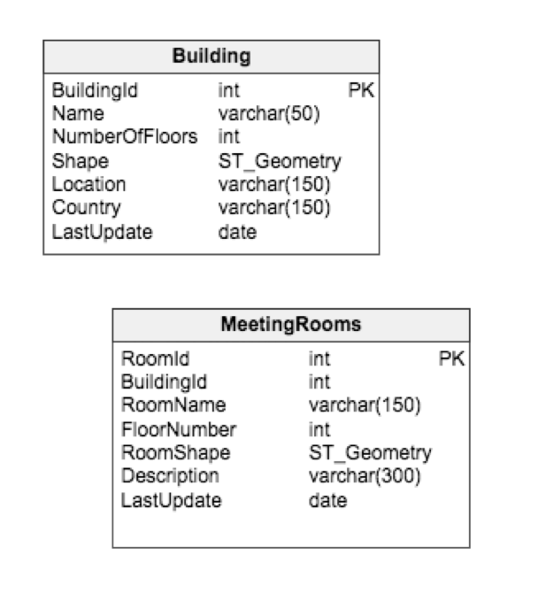

### Data Collection

The project included a significant amount of data collection the data that was collected was – Building coordinates in a polygon form, Room coordinates in point form both geo-spatial data types.

It took about 10 hours to collect the data required to populate the application and around 5 hours to prepare data in correct format in order to store in the database and about 2-3 hours to store that data in the database.

### Images Collection

Included going to several rooms in NCI to collect the images for gallery feature of the application the process was easy but time consuming. It took about a day’s time to figure out images for all rooms the process was difficult I did the image collection after developing the photo upload feature in the app which made it easy to collect the photos of the rooms with my iPhone and iPad and directly storing it to the cloud through the app.

## User requirements

* The user needs to have IOS device.
* The user will require an Apple Appstore account to download the app.
* User needs to have an active internet connection to use the application and will require to register, thus allowing user to login to the app and use all the advanced features of the application.

## Environmental requirements

The server side of the system is implemented in JavaScript and SQL and requires SAP Hana.

The IOS App requires IOS 9+. And the application’s navigation feature requires GPS enabled and a working internet connection.

## Usability requirements

The core usability requirement is to allow for an incredibly user friendly experience on using the application. The application will be concise and easily navigable. The use of lists and search will allow the user to navigate the website with ease. The application will be functional to any user, regardless of experience.

## Design and Architecture

The application is being designed and developed mainly through the use Xcode Interface builder and Swift. The design of the application is centered on creating an extremely user friendly GUI.

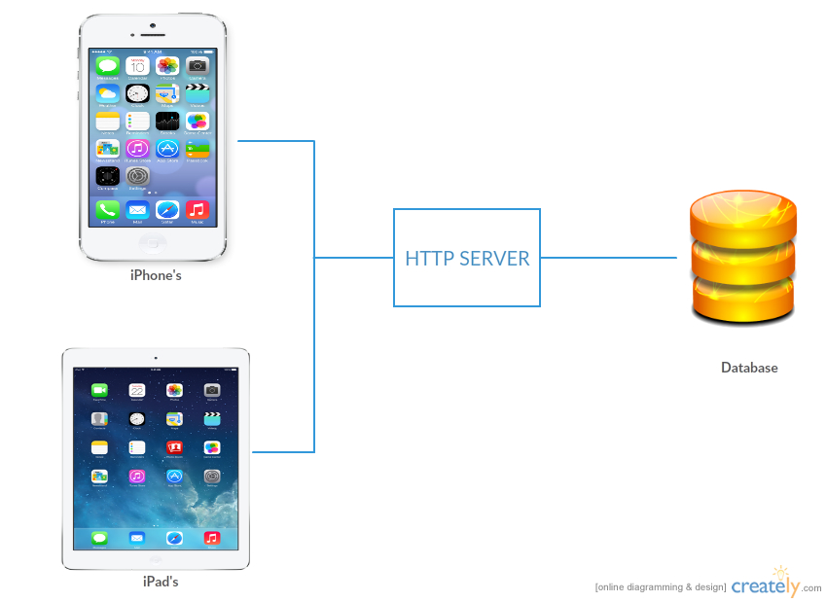

This is the architecture of the system it shows the client connects the web service through URLRequest and the service exposes the data from the database after authentication.

The Web service requires authentication to connect with client and expose JSON data and is authenticated through URLRequest.For example -

let username = "navjot"

let password = "pass1235"

let loginString = String(format: "%@:%@", username, password)

let loginData = loginString.data(using: String.Encoding.utf8)!

let base64LoginString = loginData.base64EncodedString()

// create the request

let url = URL(string: "http://mywebservice.com/service.xsjs")!

var request = URLRequest(url: url)

request.httpMethod = "POST"

request.setValue("Basic \(base64LoginString)", forHTTPHeaderField: "Authorization")

let urlConnection = NSURLConnection(request: request, delegate: self)

## Implementation

### Getting Started with Project development

#### Project Guide

This guide will help understand the requirement for opening and running this project- MeetingRoom Pro is an ios (Swift) project, in order to use open the project code we require the following:

|  |  |
| --- | --- |
| * Apple Computer or Virtual device running macOS.   (I am using MacBook Pro, 6 GB Ram, 2.3 GHz Intel Core i5) |  |

#### Installing Xcode

Xcode is an code editor. More details on it are included under Technologies section. Install Xcode on your Mac, using Appstore or this link: <https://developer.apple.com/xcode/ide/>

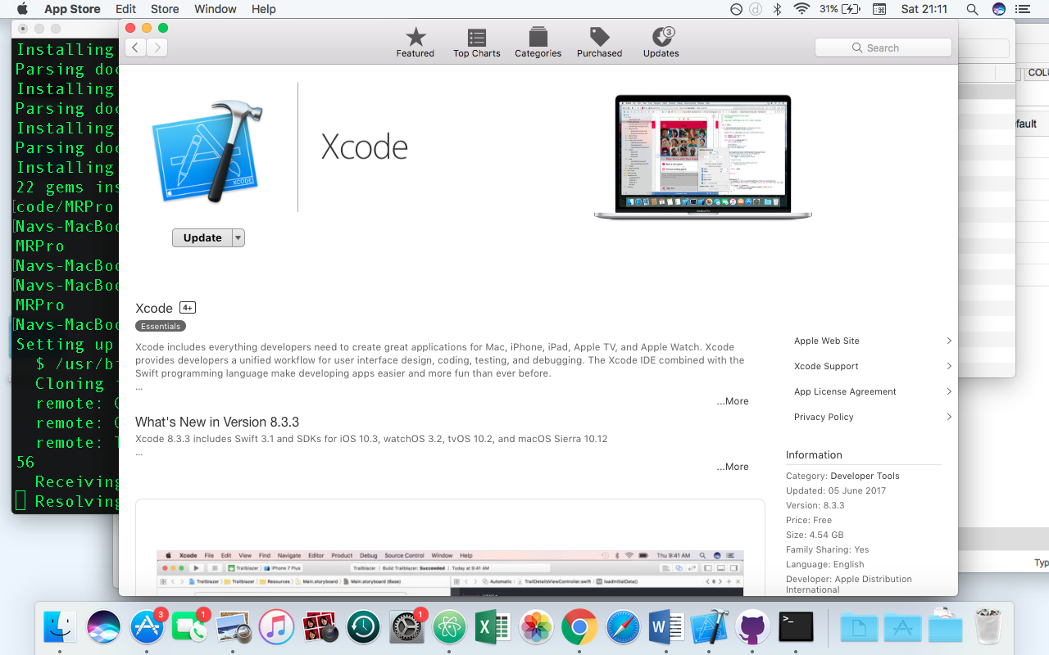

This is how a project in Xcode Ide looks like –

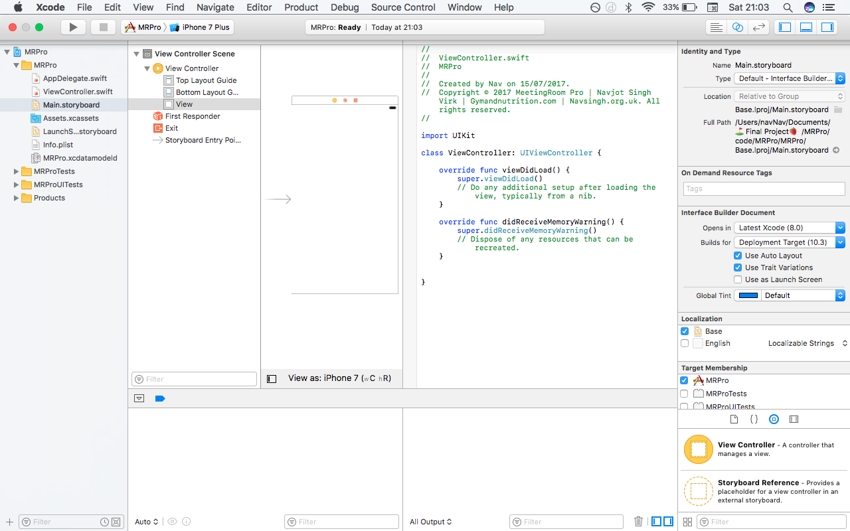

#### Opening the Project

Use MRPro.xcworkspace file to open the project in xcode.

#### Creating Project

Basic Steps that were involved in Project Creation of this project.

**Step 1:** File > New > Project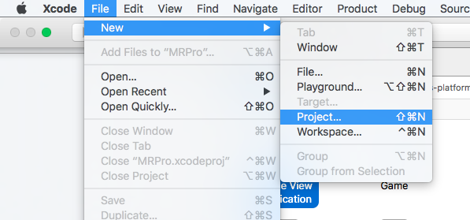

**Step 2:** Choose template – Single View Application > Next

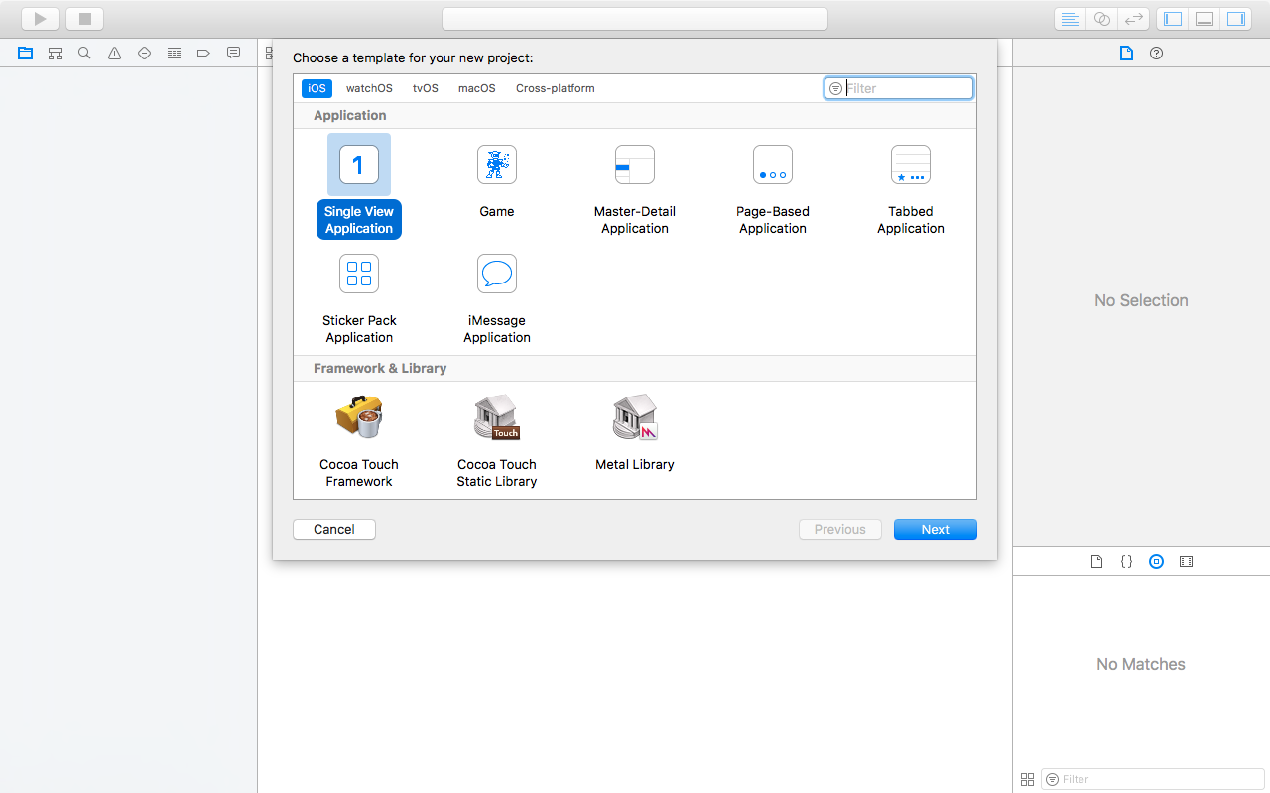

**Step 3:**

* Enter Product Name (aka. Project name) – MRPro (aka. MeetingRoom Pro)
* Select Team (Personal ios developer account – just signin with your apple id and xcode will take care of the rest)
* Organisation Identifier: ios.nsv (it could be anything (but unique) you like but it should usually make some sence and be short, simple and sweet like in this example- ios signifies its an ios app and nsv – Navjot singh virk)
* Select Language: Swift will be used for this project.
* Devices: Universal means the app will be supported on both iphones and ipads (you can also choose any one of them if you want to limit certain device type users).
* Others: Include UnitTests and UTests
* Press > Next

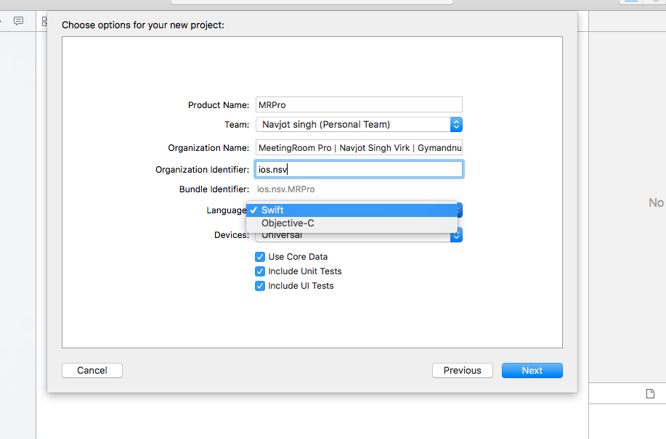

**Step 4:** Save the project on computer at location of your choice

**Step 5:** New Xcode project opens in a new window

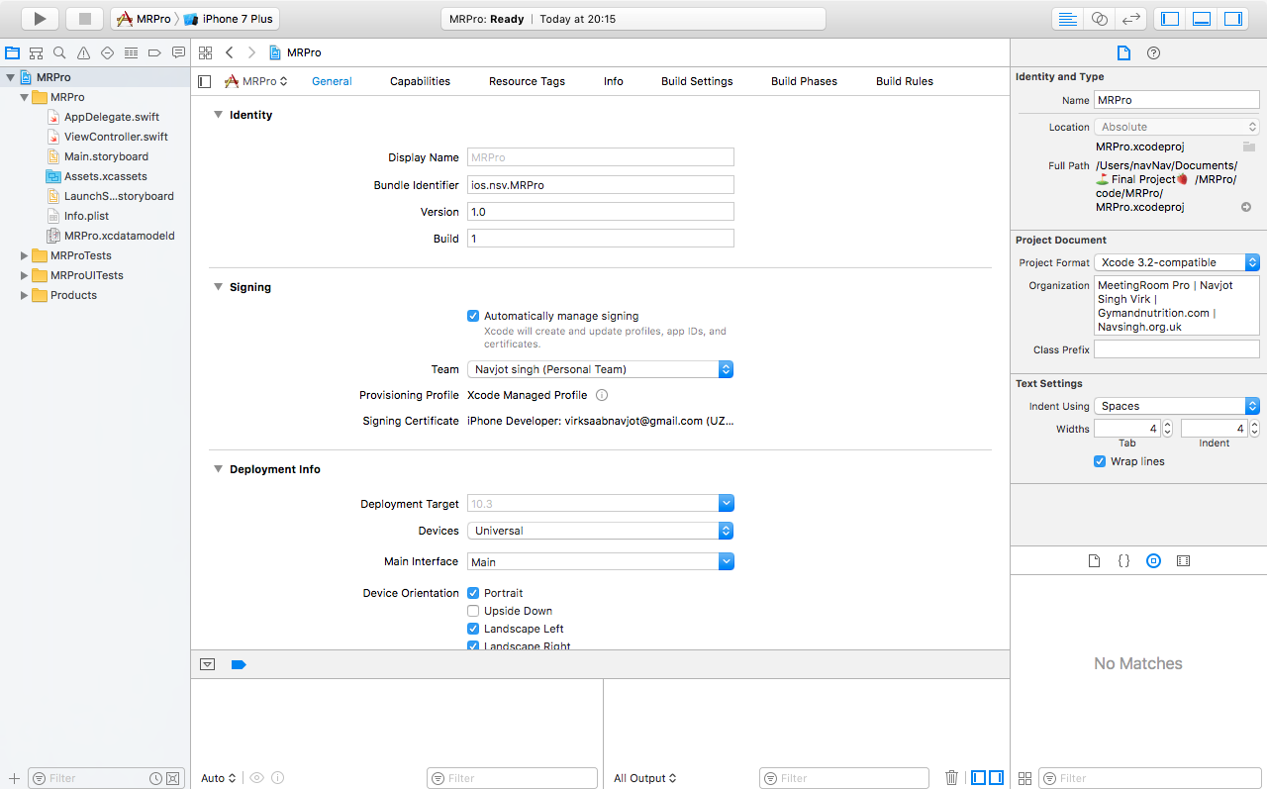

**Step 6:** At this stage project is ready and can be run on an emulator or a real ios device.

**Step 7:** Start making changes (write code)

#### Cocoapods

Installing Cocoapods (on my computer which will allow us to use different useful cocoapods available on the internet).

* Open terminal
* Run this command: **$ sudo gem install cocoapods** (cocoapods is implemented in ruby so its included as a gem on our computer, please refer to Technologies section of the report for more information regarding Cocoapods).

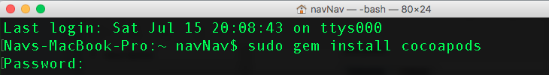

#### Create Pod File

In order to use Cocoapods we need to create a Podfile for our project.

* Open Terminal
* Navigate to the project folder
* To create the **Podfile** run this command in the terminal: **$ pod init**

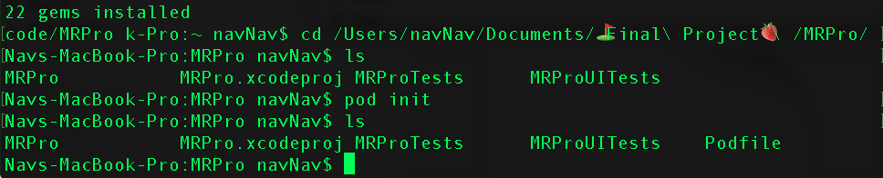

As we can see a Podfile was created when we ran the **‘ls’ command** second time to list the contents of the project folder.

* **Open Podfile** in an editor and write > **pod ‘SwiftyJSON’** to add our first pod that will help in handling JSON better (it’s a very popular library/pod among ios developer community when it comes to handling JSON in ios Swift).

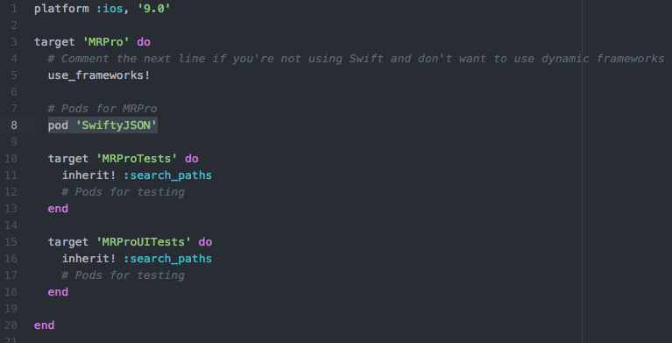

* Save Podfile > Run this command in terminal - **$ pod install** (this can take time (upto 1 to 2 hours depending on your network speed if cocoapods are not used on your computer before in order to setup cocopods master repo).

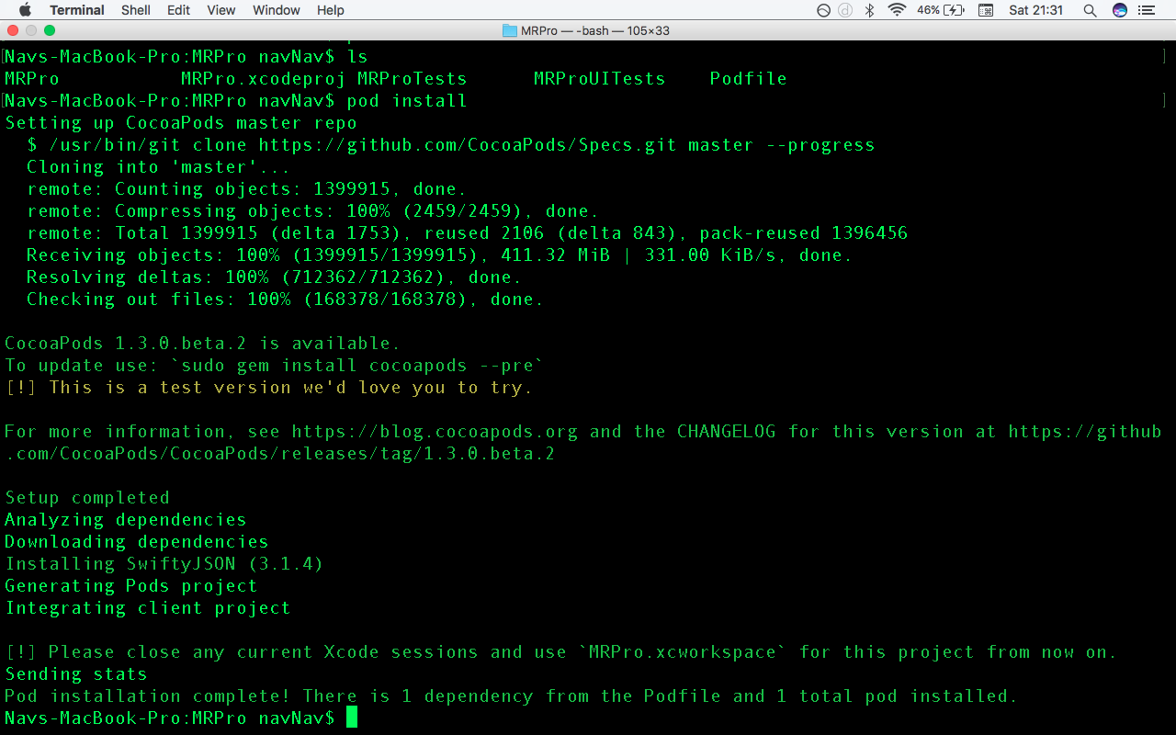

* Close project in Xcode.
* Open the newly generated – MRPro.xcworkspace. And now onwards everytime to open/work on the project MRPro.xcworkspace should be used instead of MRPro.xcodeproj
* Now at this stage the pod we installed will be available to use (Usage: import SwiftyJSON).
* All the other pods will be installed the same way.

#### Challenges, Build Fails and their solutions

1. Build fail every time after adding a new pod due to ChameleonFramework

**Details:** Build failed with 31 errors

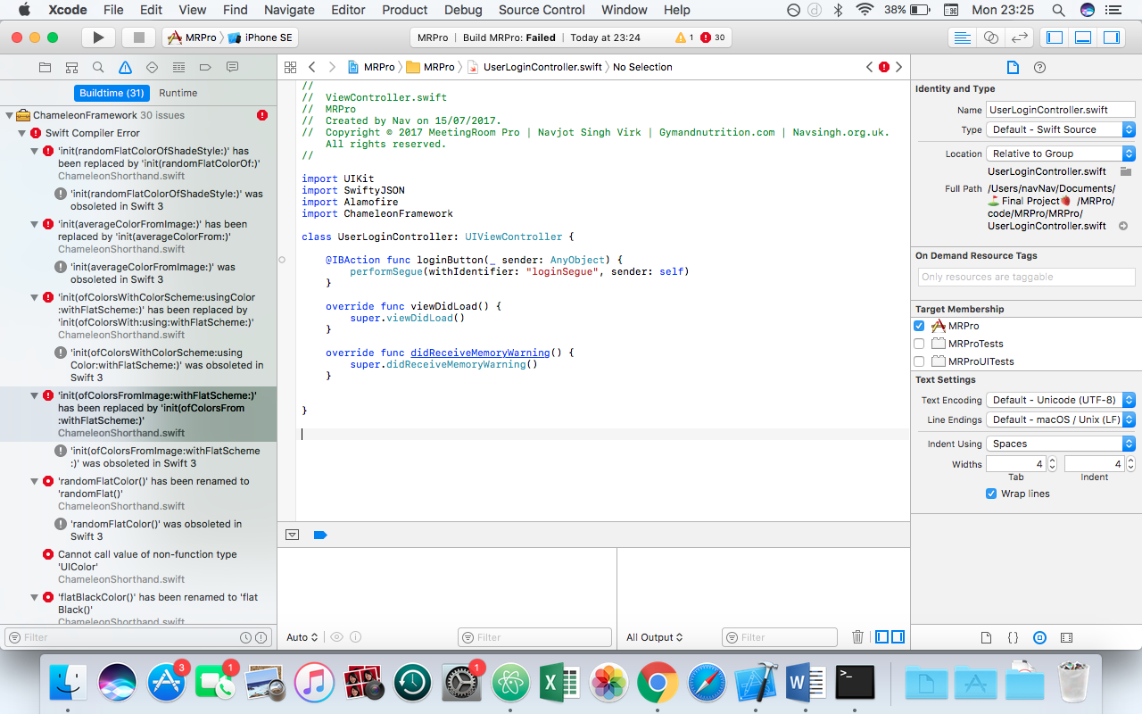

Clicking on one of the errors open the file in which errors exist. The problem here is target membership issue. As seen in the right hand pane of Xcode. Please refer to next screenshot.

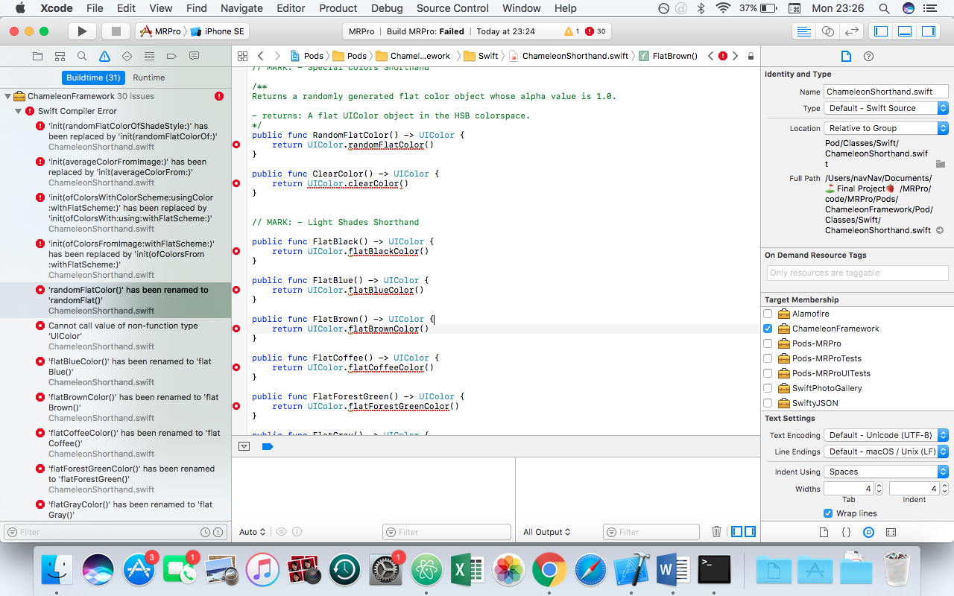

|  |  |
| --- | --- |
| Problem: Target membership is checked | Solution: Uncheck the target membership. And Clean Build  Cmd + B |
| ../../../../../Desktop/Screen%20Shot%202017-07-17%20at%2023. | ../../../../../Desktop/Screen%20Shot%202017-07-17%20at%2023. |

**Results :** The project is error free and build was successful.

|  |  |
| --- | --- |
| ../../../../../Desktop/Screen%20Shot%202017-07-17%20at%2023. | ../../../../../Desktop/Screen%20Shot%202017-07-17%20at%2023. |

Implementation is still work in progress. Below is list of classes used in the implementations of project so far.

### Client Side Implementation

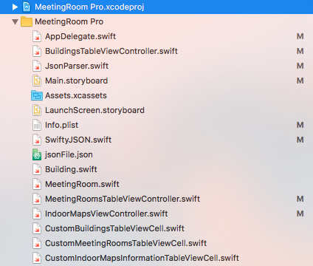

Implementation of MeetingRoom.swift Class

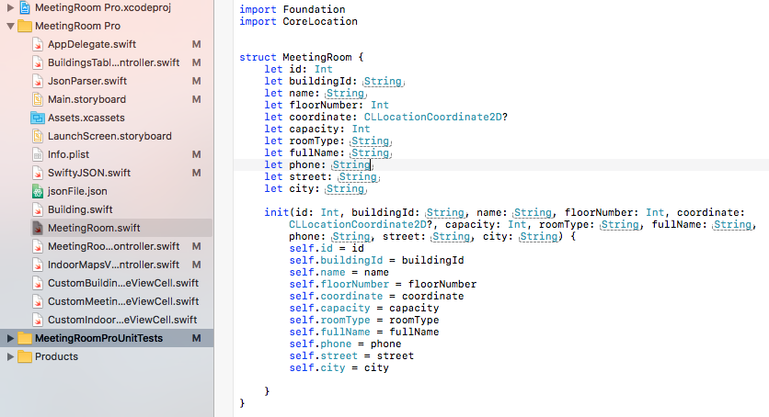

The Code snippet below is from the JsonParser.swift class, and this function parse the json with meeting room information and store it into a list of meeting room object.

var meetingRooms = [MeetingRoom]()

let json = JSON(data: jsonData, options: .mutableContainers, error: nil)

let meetingRoomsJson = json["information"][buildingIndex]["meetingRooms"]

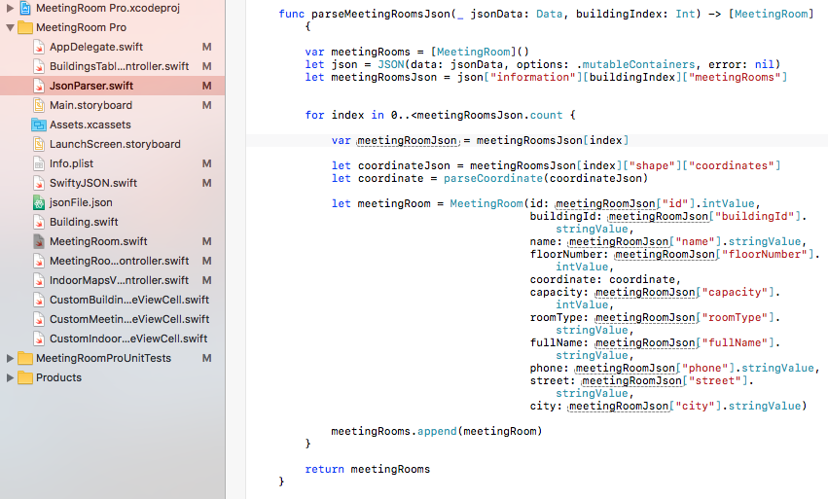

### Server Side Implementation

#### Implementation of Database Tables

**CREATE column TABLE Building (**

**BuildingId int NOT NULL,**

**BuildingName varchar(50) NOT NULL,**

**NumberOfFloors int NOT NULL,**

**Shape ST_Geometry NOT NULL,**

**City varchar(150) NOT NULL,**

**Country varchar(150) NOT NULL,**

**LastUpdate date NOT NULL,**

**PRIMARY KEY (BuildingId)**

**);**

**CREATE column TABLE MeetingRooms (**

**RoomId bigint not null primary key generated by default as IDENTITY,**

**RoomName varchar(150),**

**RoomType varchar(150),**

**BuildingId varchar(150),**

**FloorNumber int,**

**Capacity varchar(150),**

**FacilitiesNumber varchar(150),**

**Phone varchar(150),**

**Street varchar(150),**

**City varchar(150),**

**FullName varchar(150),**

**Coordinate ST_Geometry,**

**PRIMARY KEY (RoomId),**

**FOREIGN KEY (BuildingId) REFERENCES Building(BuildingId)**

**);**

**INSERT Statement for building**

**Insert into building values(1, 'NCI', 3, new ST_POLYGON('Polygon((33.294974 -2.426631, 53.294847 -6.426419, 73.294289 -6.426888, 13.294326 -6.427194, 43.294974 -6.426631))'), 'Dublin', 'Ireland', CURDATE())**

**INSERT statement for Adding Meeting rooms**

**insert into MeetingRooms values(1, 1,'SCR1', 2, new ST_Point('Point(83.294846 -4.426421)'), 'This room is located on first floor of the building', Curdate())**

## Graphical User Interface (GUI) Layout

*Note: Since, the application is under implementation stage and I am working on implementing code for parsing JSON data received from the web service, the next step will be to develop graphical user interface that will leverage the parsed data. Below are the mockup’s of how GUI will look like in future and showing how users will interact with it.*

The app will run on IOS devices that use touch screen functionality. Displaying an easy to use interface.

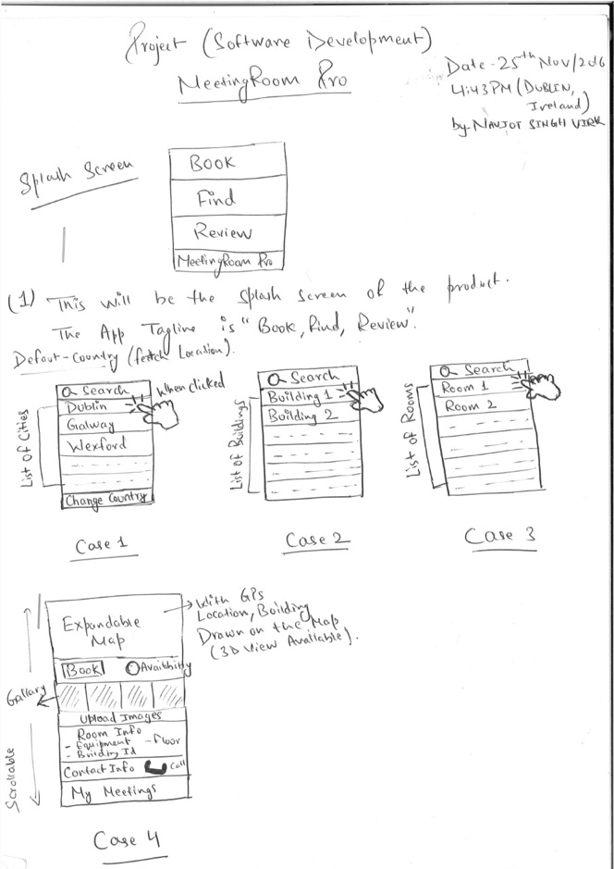

**GUI for the Application**

On starting the application, the user will see Case 1 – List of Countries and Search

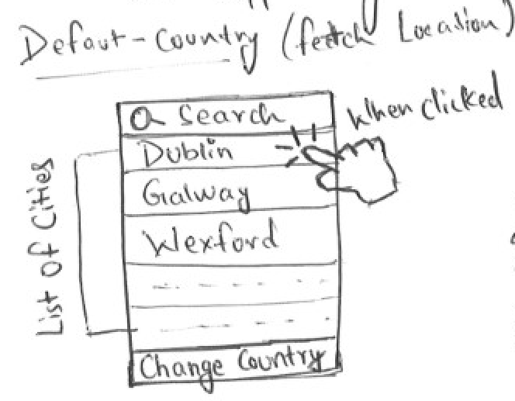

On Click - > Case 2 – List of Buildings and Search

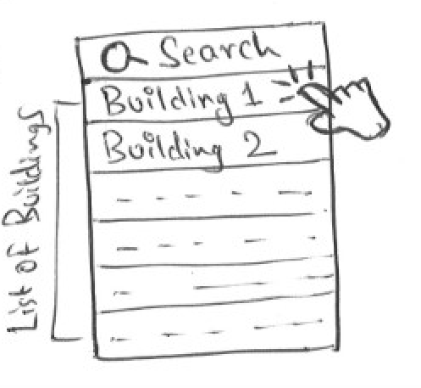

On Click - > Case 3 – List of Meeting Rooms and Search

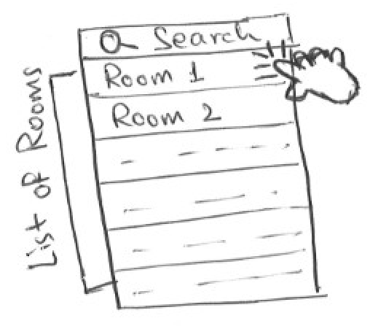

On Click -> Case 4 -> All info about selected meeting room, navigation, map, notifications, room booking system, availability, photo gallery, photo upload, call option and Meeting Rooms

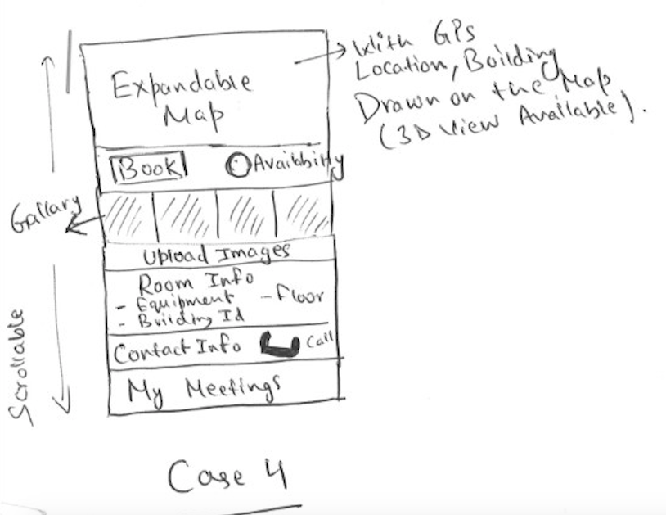

*Note: Please note Case 4 may be broken into further cases when the actual application is developed.*

## Testing

To ensure quality software is produced system and unit testing will be done. Right now the application is in implementation stage and small unit test are already been done running on code.

Unit Testing is done using XCTest in Xcode, below is a code snippet of a test ensuring the meeting room information from JSON can be parsed correctly.

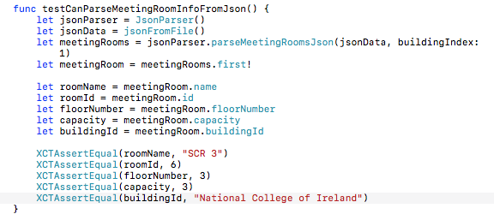

## Customer testing

Survey - <https://docs.google.com/forms/d/e/1FAIpQLSf6OT1ni3DJoIWozhp1RxZ6kJi0L0zdAWo9H75-8ZvdJquKvA/viewform>

Post and discuss results below.

The application is still under development but there has been enough customer testing for the project idea to make sure useful application shall be developed.

The most of user requirements for this project were collected/suggested by potential users during my internship in SAP SE and during the project idea presentation at SAP D-Shop innovation day on 17th and 18th August 2016 through design thinking (*heading 3*). And some were suggested my my manager at SAP SE and some by project supervisor at NCI.

MeetingRoom Pro will be an all-in-one room assistant application that will help users find meeting rooms, view them on map of building and also find relevant information like floor, room type, capacity, which building the room is located in, city, country and number of floors in that building.

The user will not have to register in order to access the app content. However, in order to review, book meeting rooms, and contribute towards gallery, the user will have to register.

Users will complete a standard registration in order to gain full access to the application features. Not only will registered users have access to content and features but will also have the permission to delete, moderate or upload content.

The users can have different account types –

* Guest *(unregistered)* – View Content Permission
* Basic User *(registered user)* – Review rooms and upload photos to gallery permission
* Moderator/Admin – Review, Upload and Delete content permissions

Design Thinking for User Requirements Definition

Design thinking is a methodology used by designers like myself to solve complex problems and find desirable solutions for clients. Design thinking can help all sorts of organizations uncover new ways of thinking and doing things.

These are the design thinking process that were used during user requirements definition –

**Empathized with Users** – Observed, engaged and tried to understand user requirements.

Because as designer / developer problems we try to solve are rarely ours so we need to understand user first to develop an application for them.

**Defined the problem –** Brought clarity and focus to design space and framed the problem.

**Idea Generation** – Allowed the users to come up with idea, features and functionality they would like to see in the application. Through brain storming and putting ideas on white board.

# Conclusions

The project idea started from me facing inconvenience in finding meeting room during my internship and I started talking to people about the idea and get their views. And I am starting the implementation of the project with beginner level understanding of Xcode and Swift and at the end of the project I would like to develop a strong understanding of these technologies and build a useful application that will assist people solve daily problems regarding meeting rooms.

The project has high potential and good commercial value when done well.

# Further development or research

I will perhaps come back to the project, as there is room for development on the idea. A more technical approach, introducing sensors and beacons to provide precise indoor navigation something I was keen to avoid in order to meet practically and functional requirements early on, could be adopted to improve navigation feature of the app. The app has the potential to expand to different industries.

There is also room for the concept to grow into the other platforms like windows phones and android.

# References

The project was not possible without the help of tutorial and videos and other resources available on the internet intensive care has been taken in order to properly reference if any work including images, text or code is used from third party resource. And I thank, deep from my heart to the authors of this work.

The report makes use of all resource available on <https://moodle.ncirl.ie> for example- the template, previous report as a starting base.

The project also makes use of several online resource including websites, blogs, papers, github repos, cocopods and other countless google searches and research which helped make this project an reality.

## Research and Code

" SAP HANA XSJS Service". *Saphanatutorial.com*. N.p., 2016. Web. 4 Dec. 2016.

"Advantages of Using Swift". *Mlsdev.com*. N.p., 2016. Web. 1 Dec. 2016.

"Swiftyjson/Swiftyjson". *GitHub*. N.p., 2016. Web. 9 Dec. 2016.

## Images

Intensive care has been taken to make sure all the images used in this report are properly referenced and the reference source url is included just below every image used form the internet. Any logo images used are the property of their individual owners and are only included in the report for educational purpose of showcasing/explaining the technology to the reader of the report and make the report more appealing to the reader as humans respond well to a combination of both text and images (then just text). The other mages used in this project report are screenshots from my own work.

Thirdly, I would like to thank my Supervisor Cristina Muntean for her availability during the project development, her useful suggestions during all the project meetings from the start to the last meeting. And her, giving me time to respond to all emails including some with silly questions.

My special thanks to our teacher Eamon Nolan as well as he was very helpful at every stage of the project development and helped resolve my confusions and gave useful answers when I needed them the most.

At, last I would like to thank my mother and family for being there for me whenever I was stressed and putting me back on track.

# Appendix

## Independent Research (Problem Solving – Storing Geo-Spatial data)

Research Document (MySQL Spatial Data Types, Storing spatial data and using it to create a Restful Web service)

**Aim:** The aim of the document is to successfully research ways to be able to store geo spatial data in MySQL database

**Why:** Currently (24 Feb, 2017) I have been using SAP Hana HCP but the issue is its not free and is very expensive to move from trail to pro version, so the better alternative is MySQL if I am successfully able to implement what I was able to do with HCP. And, the advantages will be free of cost, HCP trail needs restart every 12 hours and auto deletes after 6 days which is a big disadvantage, MySQL will allow 99% uptime for web service.

***Creating a Sample table with geometry elements ***

create table myspatialdata (id integer(7), bpolygon Geometry, mpoint Geometry);

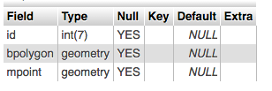

***Inserting spatial data into MySQL****

INSERT INTO myspatialdata (id, bpolygon, mpoint)

VALUES ('1','POLYGON(18 23, 0 0, 3 6, 8 9, 18 23)','POINT(18, 23)');

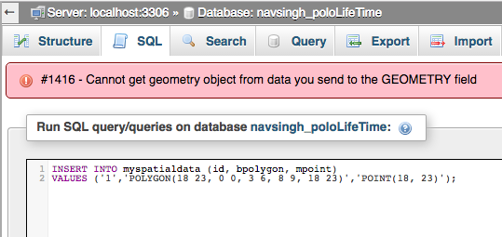

Working SQL Statement to insert spatial data in MySQL (Polygon and Point)

INSERT INTO myspatialdata (id, bpolygon, mpoint)

VALUES (1,GeomFromText('POLYGON(18 23, 0 0, 3 6, 8 9, 18 23)'),GeomFromText('POINT(18, 23)'));

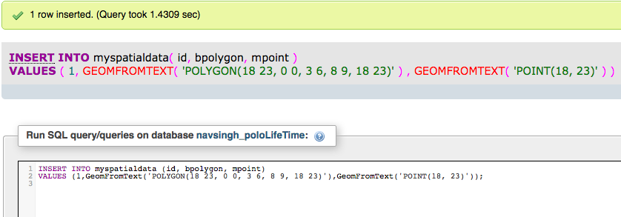

INSERT INTO myspatialdata (id, bpolygon, mpoint)

VALUES (2,GeomFromText('POLYGON(-74.13591384887695 40.93750722242824,-74.13522720336914 40.929726129575016,-74.15102005004883 40.9329683629703,-74.14329528808594 40.94256444133327)'),GeomFromText('POINT(-74.13591384887695,40.93750722242824)'));

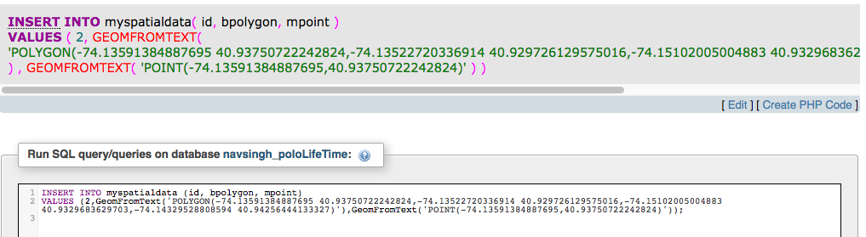

Note: Useful documentation on MySQL Spatial Data Types

<http://www.w3resource.com/mysql/mysql-spatial-data-types.php>

Inserting Coordinates into MySQL (Stack Flow)

<http://stackoverflow.com/questions/15453084/inserting-coordinates-into-mysql-polyfromtext-sql-syntax-error-returning-nul>

***The end of the Inserting Spatial data like Polygon and Point in to database table***

*************************************************

RESEARCH RESULTS: FAILED – The data is inserted in the table but in the wrong format and I am not able to retrieve it.

*************************************************

Attempt: 2

***Inserting Geo-spatial Polygon into the MySQL Database***

INSERT INTO `Buildings` (`Name`, `Shape`) VALUES ('Apt 15', PolyFromText('POLYGON((50.866753 5.686455, 50.859819 5.708942, 50.851475 5.722675, 50.841611 5.720615, 50.834023 5.708427, 50.840744 5.689373, 50.858735 5.673923, 50.866753 5.686455))'));

Reference: <https://gis.stackexchange.com/questions/23900/how-to-add-polygon-in-mysql-database>

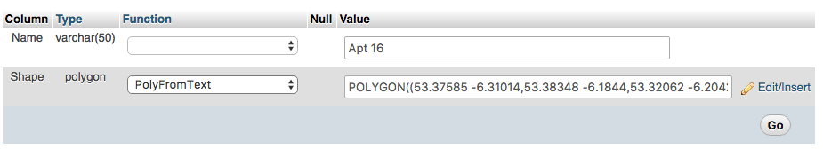

*************************************************

RESEARCH RESULTS: PASSED (Working)

– The data is inserted in the table and able to retrieve it.

*************************************************

## Project Proposal

### Objective

The objective of the project is to develop an iOS application, that allows its users to find, review and book meeting rooms. The user can search meeting rooms, upload images of the room which will be available on the app for other users for assistance, see where the meeting room is in the building on the map. The application will allow users ease of use and help quickly find info on their desired/selected meeting room like equipment available in that room etc., and additional information like which floor and my meetings tab which allows the users to see all his/her meetings and the app also allows the users to create meetings and save in the phone calendar.

**Map Feature**

Using Apple maps (MapKit) and the coordinates of buildings and meeting rooms. The building will be drawn on the map as a polygon and the meeting room as a point on the map along with the current location of the user.

**Camera Feature**

The users will be given an option to take photo through the app or choose an image from phone gallery and upload it to the application gallery.

**Gallery Feature**

A gallery of photos of the room and equipment available, the application will allow the user to upload images which will be available in gallery for other users to view.

**Review Feature**

This feature will allow the user to review the meeting room and the room ratings will be available for other users to see.

**Geo Location Feature**

The app will use geo-spatial data to display buildings and meeting rooms on the map and when a user is in a certain radius close to the meeting room. The user will receive notifications with approx. distance left from the meeting room.

And the functionality to disable this feature will also be given.

If the user has a meeting booked in a meeting room and if their phone is not within a certain radius to the meeting room, the user will receive a reminder notification. Also, the user will receive a reminder few minutes say 10 minutes before the meeting starts.

### Background

During my work placement at SAP SE, I was engaged in several meeting from my induction to my farewell meeting, there were more than 50 meetings, from team meetings to global team meetings, intern meetings and HR meetings, to employee farewell meetings which I was part of in the course of 7 months of internship.

And number one issue was finding the meeting room due to big size of the buildings, if the meeting room was close enough to my desk, it was easy enough to find the meeting room but the problem used to arise when the meeting rooms were on different floors, even different wing of the same floor and the problem was big when trying to find a meeting room on another building and some fancy names to the meeting rooms didn’t make much sense at all and the icing on the top if you are short on time i.e. have consecutive meetings to attend and the only solution available was to ask you collages if they didn’t know run towards the reception and they would show you a floor plan which sometimes didn’t made sense and overall experience in finding meeting rooms was not up to the standards to which it could be achieved.

I started some research and found other employees were facing the same issues and were just limited to using meeting rooms near their offices due the hassle of finding meeting rooms, after talking to people the user research findings were not just the interns who felt this pain, some of the very senior employees which were there for many years didn’t know where some of the meeting rooms were and since SAP is multinational company, there were always employees from different location which travelled to attend meetings and had very hard time finding the meeting room and first have to go to facilities department and the facilities member would manually assist wherever this process can be automated i.e. a simple to use application could solve this problem.

Hence, there is were the idea for the application is developed from but it is not just limited to corporate world the application can be put to use in universities and college with minor changes.

### Technical Approach

#### Mobile App / Client Application

The Client application, will be developed using apple’s new programming language : Swift 3 <https://developer.apple.com/swift/>



Reasons for Using Swift

Its fast, open-source, have to write less code and get more work done, its interactive and another motivation for using Swift for this project is, I have done some swift during internship and it’s a new language to me and I would like to learn it more in depth while working on this project.

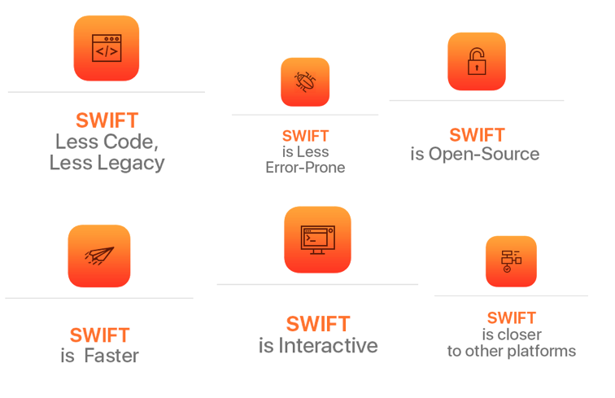

and using Xcode 8 IDE <https://developer.apple.com/xcode/>



**XCODE**

**Xcode** is an integrated development environment (IDE) containing a suite of software development tools developed by Apple for developing software for macOS, iOS, WatchOS and tvOS.

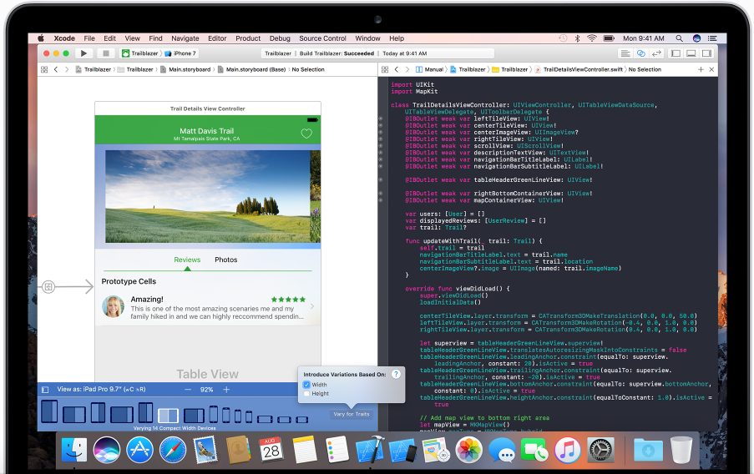

The mobile application will run on IOS devices including iPhone and iPads.

#### Backend

a JavaScript based Web service will be developed which will expose the data for the use of client app.

**On database side**: Geo-spatial features of MySQL/SAP Hana Spatial will be used.

**What is SAP Hana Spatial?**

Hana Spatial is a feature of SAP Hana

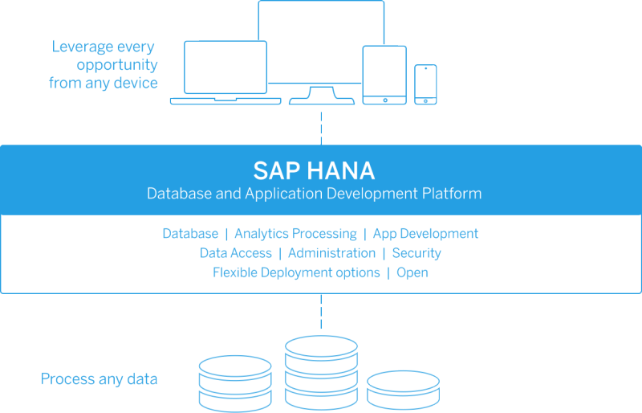

Why Hana Spatial?

HANA Spatial delivers the ability to store and process geospatial data types like ST_POINT, ST_GEOMETRY etc. Which allows to store co-ordinates for the buildings and meeting rooms for this project.

### Special resources required

This project doesn’t necessarily need any special resource, wherever the project can be taken to a different level by implementing beacons for indoor navigation or sensors to track presence of people in meeting rooms.

### Gantt Chart

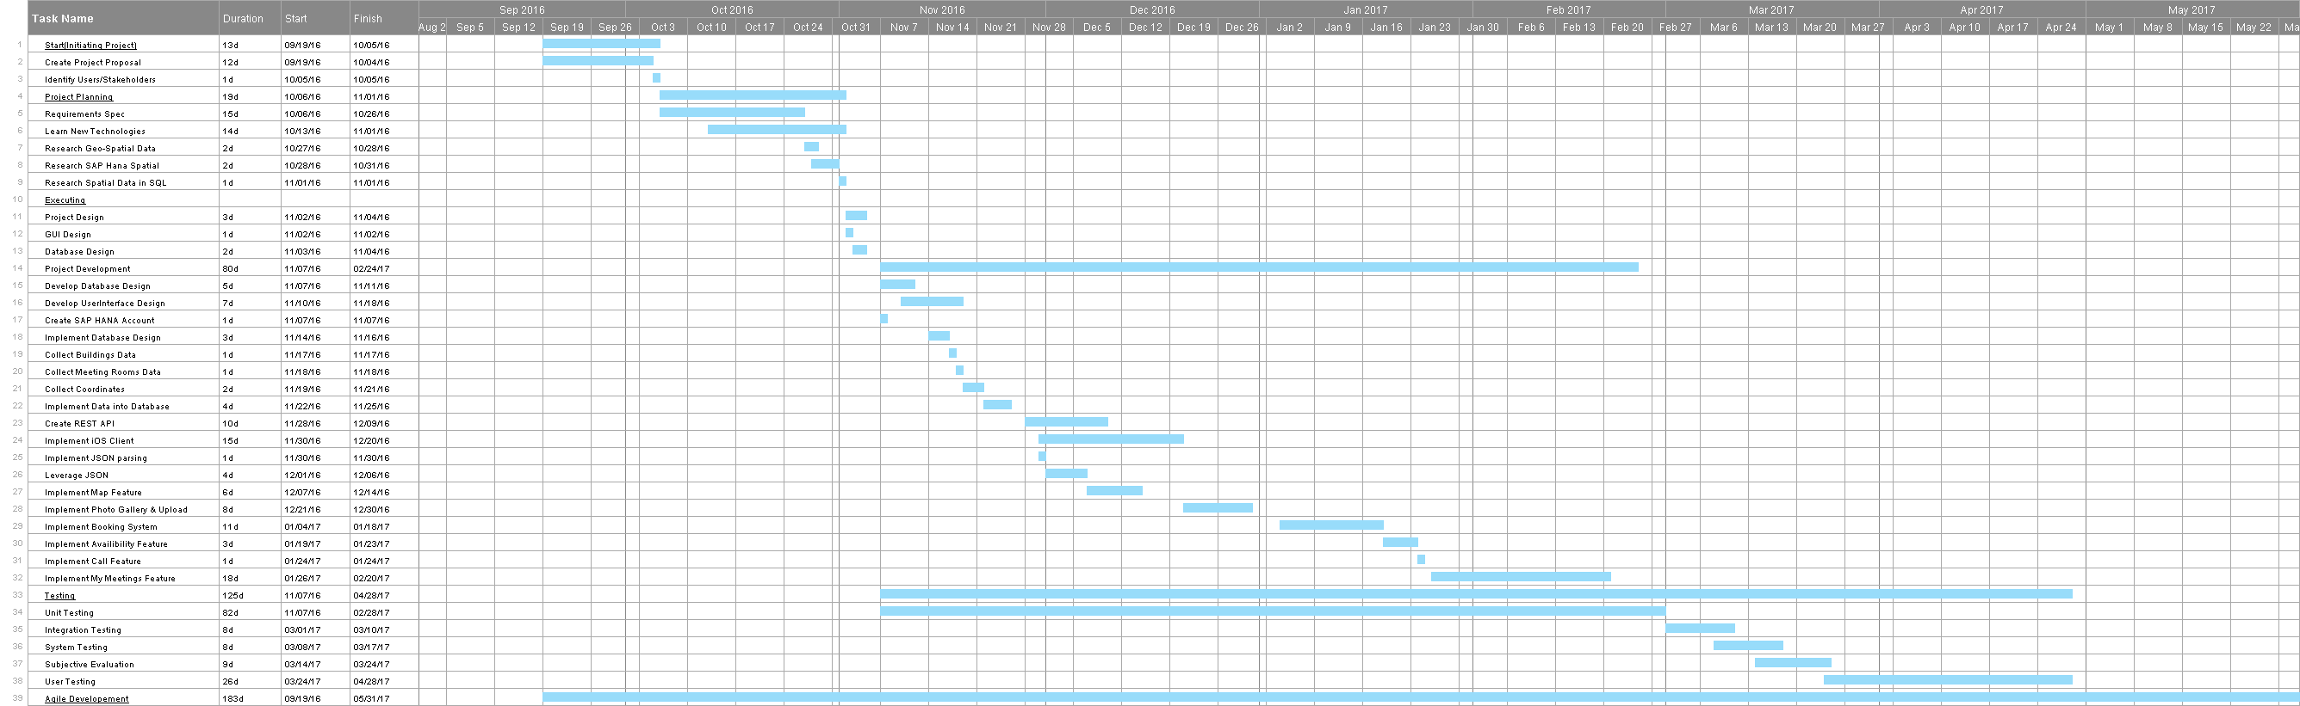

### Technical Details

Implementation languages and principle libraries:

**Frontend / Client Side:**

Swift 3 <https://developer.apple.com/swift/>

Core libraries:

* Foundation
* CoreLocation
* UIKit
* CoreLocation
* MapKit

And possibly some HTML and CSS.

3rd Party libraries

SwiftyJSON.swift <https://github.com/SwiftyJSON/SwiftyJSON>

**Server Side:**

SAP Hana Spatial database

JavaScript

MySQL

Possibly REST Architecture

### Evaluation

For Unit testing of Swift - XCTest Unit Testing framework.

For unit testing of Javascript – QUnit or Jasmine Javascript Testing Framework.

System Testing – will be performed on entire system in the context of Functional requirements and system requirements

Integration Testing – Continued research, no decision made on this at this time.

How will the system be evaluated by the end user?

* Discussion with College Staff, Corporate Organisations
* College students discussing the app and its features.
* By getting feedback on prototype.

### Proposed Supervisor

Cristina Muntean

## Project Plan

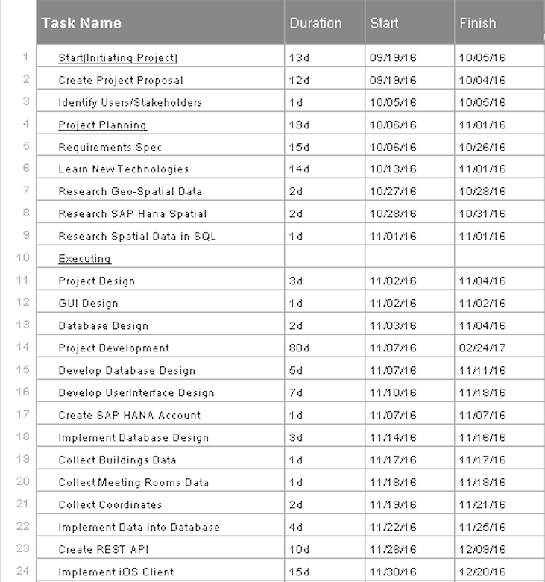

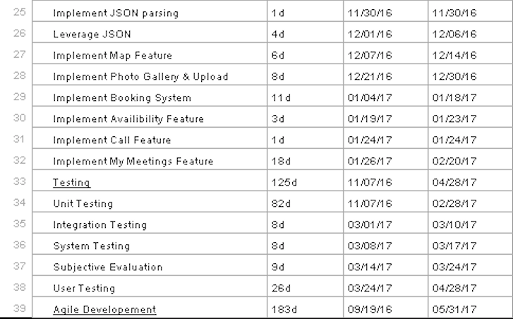

## Requirements Specifications

### Introduction

#### Purpose

The purpose of this document is to set out the requirements for the development of Meeting Room Pro project. The application assist users to find meeting rooms among multiple buildings in multiple locations, with ease of use and review rooms and find relevant information about the rooms.

The intended customers of the application are medium to big size corporate organisations with multiple buildings and hundreds of rooms. And educational institutions like universities and colleges. The target users of the application includes but not limited to – company employees (managers, team leads, interns), facilities department, It department and in educational institutes college staffs and students will be major target audience.

The intended audience for this document is myself, potential clients of the project and the academic staff at the National College of Ireland.

#### Project Scope

The scope of the project is to develop quality native IOS application allowing the users to use it on their iPads and iPhones. The application shall show the current location of user in a map view which will allow users to see how far they are from the meeting room, also user shall receive notifications, and the app shall also allow booking and availability feature and some other features. Which will attract users and potential client to get involved with the project also form my research I found no product similar to this application exist in the market. And, the project scope is more stronger due to the fact the application works out of the box (*application client can be easily used for any organisation without any prior changes or any dependencies. Only, different .csv files with building and meeting room information tailor the application for any organisation*).

I was involved in several discussions with Manuel Saez, my manager at SAP SE (internship) and my academic supervisor Christina Muntean. To elicit the following requirements

Here is a list of main features of the application:

* The app shall allow the user to book a meeting room while specifying the date and time of the meeting.
* The app should be able to read users device calendar and check if a meeting exists, the user receives a notification.
* The app shall be able to run smoothly on all iPhones and iPads.
* The app shall have responsive GUI / interface which allows the app to function properly and look good and function properly on different screen sizes.
* The system shall have a database in order to store building and meeting rooms information.
* The database shall have the capability to store geo-spatial data.
* The app must make a secure connection with backend the web service using authentication.
* The system shall have a web service to return data in either JSON/XML format, that will be displayed in the app.
* The application shall have a simple web based dashboard to allow the administrator to add more buildings and rooms with ease.
* The application shall be scalable.
* The application shall have Geo location feature so that when a user is within a certain radius of the meeting room or if outside building gets notified through a friendly notification. “Hey you are this close (*approx. location*) to your destination”.
* The application shall have a gallery to showcase photos of the room and an upload feature that allows the users to upload photos of a room which will also be available to other users to see and benefit from.
* The application shall have an expandable map with building drawn as a polygon and room as point and with apple maps most of the buildings have 3d view available which will allow the user to see the building in 3d view and find where the meeting room is located in the building.
* The application shall provide functionality to make a call from the app to key contacts of the meeting room like IT or Facilities department.

The application will be implemented using open-source programming language Swift 3 and Xcode Editor with continuous unit testing. And on the backend, SAP Hana Spatial and a JavaScript based web service.

#### Definitions, Acronyms, and Abbreviations

SAP SE – German Multinational Software Company.

NCI – National College of Ireland

SAP Hana – In memory, column oriented RDBMS.

RDBMS - Relational Database Management System.

Hana Spatial – feature of SAP Hana that allows us to store Geo-Spatial Data.

Geo Spatial Data – Data that has geographic positioning information.

GUI – Graphical User Interface

Shall - The term “*shall”* is used in this document to describe features which the system must have.

Should - The term “*should*” is used in this document to describe a feature which the system should have but may not.

Customer – The term “customer” is used in this document in context of potential users and clients.

### User Requirements Definition

The requirements that I have outlined in the project scope section of this document are that of the customer after D-Shop design thinking and several consultations with myself.

The most of user requirements for this project were collected/suggested by potential users during my internship in SAP SE and during the project idea presentation at SAP D-Shop innovation day on 17th and 18th August 2016 through design thinking (*heading 3*). And some were suggested my my manager at SAP SE and some by project supervisor at NCI.

MeetingRoom Pro will be an all-in-one room assistant application that will help users find meeting rooms, view them on map of building and also find relevant information like floor, room type, capacity, which building the room is located in, city, country and number of floors in that building.

The user will not have to register in order to access the app content. However, in order to review, book meeting rooms, and contribute towards gallery, the user will have to register.

Users will complete a standard registration in order to gain full access to the application features. Not only will registered users have access to content and features but will also have the permission to delete, moderate or upload content.

The users can have different account types –

* Guest *(unregistered)* – View Content Permission
* Basic User *(registered user)* – Review rooms and upload photos to gallery permission
* Moderator/Admin – Review, Upload and Delete content permissions

### Design Thinking for User Requirements Definition

Design thinking is a methodology used by designers like myself to solve complex problems and find desirable solutions for clients. Design thinking can help all sorts of organizations uncover new ways of thinking and doing things.

These are the design thinking process that were used during user requirements definition –

**Empathized with Users** – Observed, engaged and tried to understand user requirements.

Because as designer / developer problems we try to solve are rarely ours so we need to understand user first to develop an application for them.

**Defined the problem –** Brought clarity and focus to design space and framed the problem.

**Idea Generation** – Allowed the users to come up with idea, features and functionality they would like to see in the application. Through brain storming and putting ideas on white board.

### Requirements Specification

#### Functional requirements

Use Case Diagram System



The above Use Case Diagram provides an overview of all functional requirements of this project.

##### Requirement 1: Easy to Use GUI

###### User Story

As a user I want to have an easy to use interface so as I can navigate through the app easily with little time needed to be spent learning how to use the app

**Use Case Diagram**

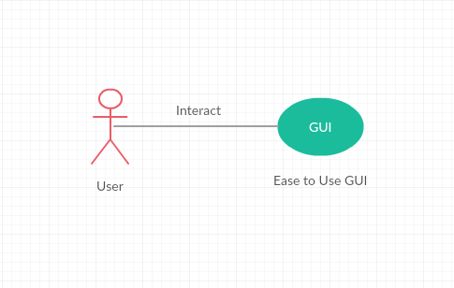

###### Description & Priority

The system shall have an easy to use graphical user interface. Navigation will be possible through the touch screen functionality of the IOS device. The design shall also be responsive so as to support different screen sizes of iPhones and iPads.

*Essential and High Priority Requirement*.

###### Requirement Activation

This requirement will be activated upon starting of the application.

###### Technical Issues

GUI Need internet connection to get data from API which will be shown in the application, slow internet connection can affect performance of the GUI.

###### Risks

Provision must be taking that not all users have a good understanding of technology and the use of mobile platforms. If the GUI is to become too complex, some users may not use the application. This requirement is at the core to the success of the system.

###### Dependencies on other requirements

N/A

##### Requirement 2: List and Find(Search)

###### User Story

As a user I want to be able to find buildings and meeting rooms with ease. Like a clickable list of buildings which then browse to list of meeting rooms also search and I can select a meeting room and find it or use other features like room booking, gallery upload etc.

###### Description & Priority

The system shall allow to search and also provide list of available buildings and meeting rooms.

*High Priority*

###### Requirement Activation

The requirement to list buildings and meeting rooms will be activated upon starting of the application and search is activated when user enters in search bar.

###### Technical Issues

N/A

###### Risks

This requirement is at the core to the success of the system as most of the requirements hereafter have a dependency on this one.

###### Dependencies on other requirements

This requirement has a dependency on requirement 1 - Easy to use GUI.

##### Requirement 3: Map / Navigation

###### User Story

As a user I want to be able to view the building highlighted on the map. Also the meeting room I am looking for along with my current location and some information about the building and room like floor number.

###### Description & Priority

The system shall have an expandable map with current location of the user and building drawn on the map.

*Optional: The application should leverage some sensors or beacons implemented in the building for effective indoor navigation as GPS may not provide accurate location indoors.*

###### Requirement Activation

The requirement will be activated when the user selects a meeting room from a list of rooms.

###### Technical Issues

N/A

###### Risks

May face some issues with current location of the user while indoors as GPS is not designed for indoors and this may affect the accuracy of the location slightly.

###### Dependencies on other requirements

N/A

##### Requirement 4: Geo Location Notifications

###### User Story

As a user I want to have notifications automatically sent to me when within a certain radius of the building or the meeting room so I am notified that the destination is close enough.

###### Description & Priority

The system shall have functionality that when a user’s smart phone comes within a certain radius of the meeting room a notification will be sent to remind them with approx. distance to the destination i.e. *"Hey, you are “approx. distance” from your destination ….".* Functionality to unsubscribe to this service should also be provided. *High priority*.

###### Requirement Activation

This requirement will only be activated if a user brings their mobile device which they have the app installed on within a certain radius of the building/meeting room. This distance will be tweaked at the system/ user testing stage of project. This service should also only occur once while finding a meeting room as if a client user was moving in and out of the geographical perimeter they will not receive multiple notifications. As stated above functionality to unsubscribe to this service should also be provided.

###### Technical Issues

N/A

###### Risks

N/A

###### Dependencies on other requirements

N/A

##### Requirement 5: User Registration

###### User Story

As a user I shall be able to easily register within seconds to use the advanced features like posting reviews and uploading photos.

###### Description & Priority

The system shall provide a standard registration and login. The requirements like booking and reviewing require registration in order to allow users to use these features.

*High Priority*

###### Requirement Activation

The requirement is activated when user wishes to book, review meeting room and upload photos of the meeting room.

###### Technical Issues

N/A

###### Risks

N/A

###### Dependencies on other requirements

N/A

##### Requirement 6: Booking System

###### User Story

As a user I want to be able to book meeting rooms through my smartphone so as I can book meeting rooms easily from anywhere.

###### Description & Priority

Functionality for users to book meeting room once selected a meeting room. This feature shall have its own page and be easy to use i.e. drop down lists to choose data and time of booking and the user shall be able to see the booked meeting rooms.

*High priority*

###### Requirement Activation

This requirement will be activated if the client user wishes to book a meeting room.

###### Technical Issues

N/A

###### Risks

This requirement is very important as some of the requirements hereafter have a dependency on this one.

###### Dependencies on other requirements

This requirement has a dependency on requirement 1 - Easy to use GUI and Requirement 2 – List and Search

##### Requirement 7: Photo Gallery

###### User Story

As a user I shall be able to see some photos of the meeting room showing the equipment available and size of room straight from the app.

###### Description & Priority

The system shall have a photo gallery with multiple photos of the room.

*Medium Priority*

###### Requirement Activation

The requirement will be activated when a user selects a meeting room from the list.

###### Technical Issues

N/A

###### Risks

N/A

###### Dependencies on other requirements

N/A

##### Requirement 8: Photo Upload

###### User Story

As a user I shall be able to upload some picture from my phone gallery or camera if some pictures are missing in the Gallery.

###### Description & Priority

The system shall allow all registered users to upload images of the rooms to the photo gallery. And also allows users with admins and moderator accounts to delete the low quality images straight from the app.

*High Priority*

###### Requirement Activation

The requirement will be activated when user wishes to upload an image.

###### Technical Issues

N/A

###### Risks

Some users may try to spam or misuse this feature.

###### Dependencies on other requirements

The requirement has a dependency on requirement 7: Photo Gallery

##### Requirement 9: Review

###### User Story

As a user I would like to see some reviews available about the room and its equipment and also like the functionality to review it myself.

###### Description & Priority

The system shall allow the registered users to review meeting rooms based on different parameters like – functionality and quality of available equipment, if the room temperature was good and so on as user feedback will help improve the quality of the meeting rooms and the meeting rooms getting low ratings can be improved and get more attention from IT and Facilities department.

*Medium Priority*

###### Requirement Activation

The requirement will be activated when the user wishes to review meeting room.

###### Technical Issues

N/A

###### Risks

N/A

###### Dependencies on other requirements

N/A

##### Requirement 10: My Meetings

(Calendar event / Reminder of booked meeting feature)

###### User Story

As a user I would like to see all my meetings and simply start the map navigation.

###### Description & Priority

The system shall provide a list of meetings booked for the user and the user will receive a reminder notification. The system should be able write and read meetings to and from the device calendar.

###### Requirement Activation

The requirement will be activated when the user has some meetings in their calendar.

Medium to Low Priority

###### Technical Issues

N/A

###### Risks

N/A

###### Dependencies on other requirements

The requirement has dependency on requirement 6: Booking System

##### Requirement 11: Call

###### User Story

As a user if I am in a meeting and some equipment is not working I should be able to contact the key contacts for the room that can fix the problem for me i.e. make a quick call from the app.

###### Description & Priority

The system shall provide contact information for key contacts and allow user to make a call.

###### Requirement Activation

The requirement is activated if the users wishes to make a call through there phone.

###### Technical Issues

N/A

###### Risks

N/A

###### Dependencies on other requirements

Requires a sim card to make calls via the phone.

#### Non-Functional Requirements

##### Scalability requirement

###### User Story

N/A

###### Description and Priority

With regards to the intended number of users in big and medium cooperate organisation with thousands of employees and teachers and students in educational institutes and the projected load scenarios, the intention is for the system to be able to serve queries in thousands/ day (in large part during the 9-5 peak traffic hours) and the application shall also be scalable to use for any organisation with little to no changes to the app’s code.

*High Priority*

##### Availability requirement

###### User Story

As a user I want to be able to access the app at any time I wish.

###### Description and Priority

The app shall be accessible at any time of the day on any day of the year. *High priority*.

##### Physical requirement

###### User Story

As a user I want to be able to access the app from anywhere.

###### Description and Priority

The app shall work on mobile devices. *High priority*.

##### Security and Privacy requirement

###### User Story

As a user I want the app to be secure like my password must be safe.

###### Description and Priority

The app shall achieve security through encryption and SSL certificate when connecting to the server. *High priority*

##### Reliability requirement

###### User Story

As a user I want to the app to be reliable.

###### Description and Priority

The app shall be reliable i.e. stable and consistent of what is expected out of it. *High priority*.

##### Maintainability requirement

###### User Story

N/A

###### Description and Priority

The app shall be easy to maintain on daily basics, and it should be easy to fix bugs, add new features, increase performance and easier for others to maintain the software.

*High Priority*

### Interface requirements

#### GUI

The app will run on IOS devices that use touch screen functionality. Below is a quick mock up of the GUI for showing how the user will interact with it. Displaying an easy to use interface. *Note: These mock ups can be seen abstractions of what will be finally implemented.*



**GUI for the Application**

On starting the application, the user will see Case 1 – List of Countries and Search



On Click - > Case 2 – List of Buildings and Search



On Click - > Case 3 – List of Meeting Rooms and Search



On Click -> Case 4 -> All info about selected meeting room, navigation, map, notifications, room booking system, availability, photo gallery, photo upload, call option and Meeting Rooms



*Note: Please note Case 4 may be broken into further cases when the actual application is developed.*

#### Application Programming Interfaces (API)

The following is a list of device APIs which the system will implement:

* Apple MapKit
* Apple CoreLocation
* Apple Foundation
* Apple UIKit
* Apple XCTest
* SwiftyJSON (3rd Party)

#### Database

The system will interface with a database that stores information about buildings, meeting rooms, users, bookings and photo gallery.

Relational database tables for the following list will be developed:

* Buildings
* Meeting Rooms
* Users
* Bookings
* Reviews
* Photo Gallery

### System Architecture

I have settled on the particular system architecture as to create a consistent and fully functional system. The idea being to create architecture with potential for growth, yet for the system to be fully functional and operative from the beginning.

Users will have the initial option to register or not with the application. With registered users having the opportunity to upload photos, review rooms and book rooms.

On the middle tier will be the Presentation layer containing a REST API, a Business logic layer and a Data access layer(DAL). Finally, the Data layer which will be a SAP Hana database.

This architecture will be keeping with good practice maintaining good "separation of concerns " allowing for a loosely coupled system which will be easy to maintain and scalable if needs arise.



### System Evolution

The system can be extended over time as new technologies are introduced. Like aspects of indoor navigation can be brought to the project. The displayed content on the app will continually change, allowing for evolution within the application.

After the app has been in use for a period of time and if successful it may be possible to perform analytics on some of the data been gathered and stored by the app which may be of some benefit to the business. This will be looked at in further detail at a point in the future.

## Monthly Journals

### Reflective Journal 1

**Student name:** Navjot Singh Virk, x13112406

**Degree:** BSc. Honors in Computing (Software Development)

**Month:** September 2016

**Type:** Weekly Basis

#### Introduction

My name is Navjot Singh, 21 years old, passionate about technology, research and sports, finished my 7 months’ work placement with SAP SE in August 2016 to get back to college to finish 4th year of BSc honors in Computing in my chosen stream Software Development at National College of Ireland. At, SAP I worked with different projects with focus on iOS development using Swift which I love now. I feel satisfied while coding in general but love Java and Swift the most and enjoy making software, websites and mobile application both iOS and Android in my free time. Alongside, college I do freelancing since first year of college which provides me with real world experience and help me support my financials and college tuition and expenses. Currently, I am working with a client in Dublin on a marketplace website project.

Computing is my first love but I enjoy other things too like I love to read emotions in people and learn about human psychology, communication skills and some business and marketing as well which connects me to my roots which is my family business where I used to help my Dad while back home in school years.

I feel very confident to start my 4th year with the support of teachers and fellow classmates and friends and want to perform the best of me as in this last year I want to get better each and every day in every aspect of my life studies, gym, table tennis as these college­­ years won’t come back and I want to create memories here at National College of Ireland.

And I am absolutely delighted about starting the Software Project and would love to create a lovely piece of software that could be useful to people and make my well-wishers proud.

#### First month 19th Sept to 7th October

Attended first class on 19th of September with joy of finishing 3rd year and realising 3 years has gone fast and this final year is the one that need the most attention and I have decided to dedicate few hours each day to my studies and some extra hours on weekends and focus on the project continuously and try to work on project with an agile approach which I followed during my work placement.

**Week 1 (19th to 23rd)**

Attended first class from Eamon and received good tips and notes to get us started and Eamon explained us how things with work for this semester and a brief overview of 4th year project after class reconnected with classmates and went to library to research on an idea I was thinking could be a good software project for my 4th year project and also looking for alternate ideas as well just having my options open.

Continued the research for on the idea and to decide which programming language, tools and technology to use to get best out of my skills and also ensuring the project, I select/work on should stand out and push me out of my comfort zone to get results that I wish to get in my final year project.

Read the past year project reports available on Moodle and information on plagiarism and time management for good results.

Received the Project Pitch schedule were in the 3rd week all students had to present their idea in front of a panel of teacher without any props like presentation files, wireframes etc. Which was a little breath taking for some of us?

Overall, I believe first week was a good eye opener on what challenges to aspect in later weeks.

**Week 2 (26th to 30th)**

Monday, continued the research and discussed my ideas with Eamon and asked questions to clarify my doubts on What Eamon and other teachers will be expecting from us during the project pitch and on Thursday decided to go ahead with an idea that I researched about in my work placement and uploaded the Presentation file for the project pitch next which other lecturers would see to look if my idea had a potential to be developed further.

This week has been though since making a choice out of 100’s of ideas floating in your mind has never been an easy task for me and I believe almost everyone in the class felt the same emotion.

**Week 3 (3rd to 7th October)**

Monday started with a lot of questions asked in class and Eamon answered them all which I feel was helpful plus Eamon also delivered a little harsh speech to motivate the students to going to find an idea if they haven’t already.

And Wednesday 5th Oct, at 4:10 pm this was the time for my project pitch went 15 mins early outside the room to ensure I would be calm and collect during the project pitch. Exactly at 4:10 pm, Paul Stynes the chairperson for my project pitch came to call me for the pitch was a tough moment because know I had to present the idea I had been researching all this time and I have to deliver.

Started my Project Pitch,

My Project idea is to Create an iOS application for finding meeting rooms and people in a organisation or an educational institute, I have chosen this idea as I believe the idea has a good commercial implication as I when I was doing my work placement at SAP SE, I myself struggled finding meeting rooms at times and also found later other people were facing the same problem as well even employees that have been there for years would not know the meeting rooms and people in other SAP building and sometimes on different floors of the same building.

#### My Achievements

This month had been a good productive month can’t wait to know if the panel will approve my idea or ask me for some improvements as they suggested during the project pitch.

Overall, a good month. Worked well and would like to continue to work the same way and but would like to work even harder next month plus also send more time in library to research and work on the project.

#### Supervisor Meetings

We haven’t been assigned a supervisor yet but during this month I had a lot of chats with Eamon regarding project and asked questions and cleared my doubts.

I have presented my project idea to the panel of teachers.

Mr. Paul Stynes (Chairperson)

Mr. Ralf Bierig (Judge 2)

Mr. Eugene McLaughlin (Judge 3)

Date of Meeting: Wednesday, 5th Sept 2016 at 4:10 pm

Items discussed: Project Idea

Action Items: Waiting for approval on project idea.

### Reflective Journal 2

**Student name:** Navjot Singh Virk, x13112406

**Degree:** BSc. Honors in Computing (Software Development)

**Month:** October 2016

**Type:** Weekly Basis

#### Introduction

Last month every student presented their ideas to a panel of teachers and this document will provide a summary of the tasks and progress I made on weekly basis in second month after the completion of first month for my software project.

**Week 4 (10th Oct - 14th Oct)**

First few days of the week went nail biting waiting for the project pitch results. Then, our teacher Eamon announced the results in class which students got their project idea approved and which were not luck enough and had to select from teachers proposed ideas.

And luckily, the panel – Mr. Paul Stynes (Chairperson), Mr. Ralf Bierig (Judge 2)

Mr. Eugene McLaughlin (Judge 3)

Approved my project idea with 3 Yes ticks from all 3 teachers and I felt very confident and happy about it, I felt teachers appreciated my idea and know its my responsibility towards them that I deliver well and prove myself that the idea I proposed can be developed and will help people solve daily problems of finding rooms through my iOS application – Room Assistant.

And towards, the end of the week I started the project proposal document.

**Week 5 (17th Oct - 21st Oct)**

On Monday, worked on Project proposal and created a Github repo for the project, for source control.

Github repository: <https://github.com/Virksaabnavjot/RoomAssistant>

But sadly by Tuesday, I felt sick and went to saw a doctor and was recommended a weeks rest and could not work on the proposal or attend college for the rest of the week.

**Project proposal submission on Friday (I submitted what I finished before getting sick and informed my teacher Eamon Nolan).**

**Week 6 (24th Oct - 28th Oct)**

Felt a little healthy and again started working and completed the things that were left to finish in the project proposal.

By Wednesday, I started Requirements Specification Document and worked on it rest of the week.

And during this week, I was assigned a supervisor.

My supervisor: Cristina Hava Muntean

**Week 7 (31st Oct - 4th Nov)**

**Reading Week**

Reading week is the week I love since first year, it allows to catch up if left behind in any module and prepare for the upcoming tests and assignments.

Since, we have major CA test coming up for Web Services and API’s when back to college after reading week, like most of the students have been studying for the test and also continued dedicating some time each day to requirements specification document and some research on the project.

#### My Achievements

This month was good, recovered from bad health and completed a lot of work.

Finished the Project proposal, working on requirements specifications document and also worked hard in other modules and submitted a chess project feeling very motivated good progress happy with myself the way I am going and hope to go the same positive path for the rest of the year.

#### Supervisor Meeting

I have contacted my supervisor and the first meeting is due on 10 November.

Supervisor: Cristina Hava Muntean

### Reflective Journal 3 (November)

**Student name:** Navjot Singh Virk, x13112406

**Degree:** BSc. Honors in Computing (Software Development)

**Month:** November 2016

**Type:** Monthly Basis

#### Introduction

Last month was good and project proposal was completed and I was working on requirements specification document.

#### My Achievements

This month, I have finished the requirements specification document and stepped a SAP Hana Trail account, finished the database design and implemented it in the database, implemented a JavaScript service that returns JSON which our client uses to display information and provide functionality in the app.

With suggestions from my supervisor made some changes to project proposal document and requirements spec document to add few more feature which I will be working on next semester.

Implement the application in Swift 3 using Xcode and implemented features like list view to show buildings and meeting rooms and a map using Mapkit to display building as a polygon and meeting room as a point on the map and display current location of the user using CoreLocation.

Also, working on the Technical report about 70% finished and getting the project ready for mid term presentation.

#### My Reflection

Absolutely delighted with this month and a lot of functionality was implemented this month and some big documents like tech report are almost done. So, I feel proud about this month the only thing that didn’t go smooth in the beginning was parsing JSON in Swift but luckily found an open source library to take care of that effectively.

#### Intended Changes

Finish Technical Report and Keep updating project documents to achieve highest possible quality.

#### Supervisor Meeting

Supervisor: Cristina Hava Muntean

Supervisor meetings this month were very productive Cristina asked a couple of questions about the project and suggested improvements and provided with good advice on how to manage time and get better results and develop a high quality application.